|  |
| --- |
| https://bostoncommon-magazine.com/get/files/image/migration/content_heist.gif |
| Rogues’ Gallery  The Art of Theft  C:\Users\Stuart Adams\Desktop\PNG\ART DECO 3.png  Stuart Adams, Ben Tracy, Alistair Buchanan, Gary Malcolmson B00265262, B00307589, B00227422, B00307865 |
| |  |  |  | | --- | --- | --- | | Team Corgistan | 12/2/16 | Computer Games Technology | |

1 Game Overview 3

1.1 Game Concept 3

1.2 Feature Set 3

1.3 Genre: 4

1.4 Target Platforms: 4

1.5 Target Market: 4

1.6 Look and Feel: 5

1.7 Scope: 5

2 Gameplay and Mechanics 7

2.1 Gameplay 7

2.2 Mechanics 8

2.3 Screen Flow 11

2.4 Game Options 11

3 Setting, Story and Characters 12

3.1 Setting 12

3.2 Story 12

3.3 Characters 12

4 Level Design 15

4.1 Objectives 15

4.2 Example Level: Kelvingrove Art Gallery 15

4.3 Tutorial Level 16

5 Interface 18

5.1 Controls 18

5.2 Visual Interface 19

6 Art 23

6.1 Style 23

6.2 Influences 23

6.3 Concept Art 25

7 Audio 26

7.1 Music 26

7.2 Voice Work 26

7.3 Sound Effects 26

8 Technical Design Document 27

8.1 Target Hardware 27

8.2 Development Hardware and Software 27

8.3 Development procedures and standards 28

8.4 Game Engine 29

8.5 External Libraries 30

8.6 Networking 30

8.7 Graphics 31

8.8 Code Overview 31

8.9 File Formats 33

9 Business Analysis 34

9.1 Market Research 34

9.2 Pricing and Sales Platforms 37

9.3 Video Games Tax Relief (VGTR) 42

9.4 Sales Projections 42

9.5 Summary and Conclusions 42

10 Marketing Strategy 43

10.1 Social Media 43

10.2 New Media/Influencers 43

10.3 Traditional Media 44

10.4 Exhibitions 44

10.5 Advertising 44

10.6 Budget Breakdown 45

11 Management 46

11.1 Approach 46

11.2 Schedule 47

11.3 Risk Analysis 47

11.4 Test Planning/Strategies 48

12 GDD Development 51

12.1 Schedule 51

12.2 Meetings 51

12.3 Roles 51

13 Bibliography 52

14 Appendices 53

9 Business Analysis 53

11 Management 53

12 GDD Development 53

# Game Overview

## Game Concept

Rogues Gallery is a top down fast paced asymmetrical stealth game with a retrofuturistic style and a light hearted tone. The game is primarily targeted at core gamers aged twelve and older. The game is not specifically targeted at one gender or demographic as the concept is quite niche and restricting the intended player base in such a way would not be beneficial as far as sales are concerned. The game is planned to be released on PC via the Steam platform.

The game features two teams, one of thieves and one of guards who play against each other in various art galleries and museums. The thieves are given the task of stealing a work of art from somewhere in the museum, while the guards have to stop them from doing so. The guards can win by keeping the thieves away from the target long enough for the time limit to run out, or by capturing all the thieves. The thieves are only able to win if one of them successfully manages to procure the target item and escape the area with it before the game timer runs out.

The guards patrol the levels with a number of obstacles and traps designed to keep the thieves at from achieving their goal. Each guard has unique abilities which aids them in capturing and detaining the thieves. The thieves in turn have Environmental Kits which they can choose from at the start of the game to allow them to overcome or circumvent these obstacles, each thief character also has an ability designed to help them escape or hide from guards.

The game is divided into rounds of no more than 5 minutes each, after which the teams switch roles, the players who were playing as the guards now play as the thieves and vice versa. This is done so as to allow the players to properly experience and enjoy the differences between the two teams. The short rounds are intended to allow the player’s ample time to enjoy each team while not being so long as to cause fatigue.

## Feature Set

### General features

Varied Locations: Rogues Gallery is set in a series of art galleries and museums from around the UK. The levels are based on real museums and galleries, however the layouts of the areas do not conform to their real life counterparts in order to make the maps more exciting and engaging for the player as opposed to going for accuracy.

3 Game Modes:

* Standard mode: Thieves vs Guards - teams play as either the thieves or the guards, stealing or guarding artefacts from a gallery.
* Gallery Wars: Two teams consisting of both thieves and guards battle it out in opposing galleries to steal the other team’s valuables while protecting their own.
* Tutorial: A series of small tutorial missions designed to teach players the game's mechanics as well as a sandbox level in which there are areas for the player to practice character's individual abilities in a safe environment.

Art: 2D sprite based graphics. Character designs are inspired by Film Noir, spy movies and classic thrillers, while environmental design are inspired by the architectural trends of the 40’s-60’s.

Asymmetrical Gameplay: The gameplay is of asymmetrical nature as the two teams have differing skills and abilities as well as different goals and overall playstyles.

### Gameplay Features

The gameplay is fast paced, owing to the 5-minute time limit and cat-and-mouse gameplay. The guards have abilities allowing them to quickly subdue thieves, while the thieves have to rely on stealth to avoid capture and steal their target.

Each character in the thieves and guard teams have different abilities that they can use to aid them in achieving their goals. Teams with different character loadouts have a different set of skills and abilities, changing the dynamic and inspiring a different kind of strategy and play. From disabling security cameras to crawling through unprotected vents, there is a number of ways for players to use the environment to their advantage.

Games in the stealth genre usually allow the player to infiltrate enemy territory without their knowledge. However, in Rogues Gallery, the enemy team always know what they are up against. This adds tension - the guards know that the thieves are there, but do not know where they are or what they are stealing. The thieves know that the guards are there, but not where they are or what they are guarding.

## Genre:

Rogues Gallery is an Asymmetrical Top-Down Stealth-Action Heist game. The two teams feature different goals and playstyles. The thieves play in a stealth-action style - they attempt to avoid the guards, steal the item and get out without being caught. The guards play in a more action-oriented style; they attempt to capture the infiltrating thieves and protect the galleries’ artwork.

The thieves’ use of escape techniques and sabotage helps to emphasise the stealth aspect of the game, whereas the guards’ melee attacks, ranged weapons and physical abilities - such as the charging tackle and the room breaching - make for a more action-oriented game. This disparity allows for a greater range of gameplay options, but makes genre definition somewhat difficult.

## Target Platforms:

Rogues Gallery will initially be released for Windows PCs. After this we will look into porting to Mac/Linux as well as investigate releasing on consoles (primarily the Xbox One and PlayStation 4). We feel there is a good market for this game on consoles and a successful Windows release will give us both the funds and confidence to pursue these other platforms. We will first be releasing on Steam, however we would like to explore selling on other stores such as the Humble Store, Itch.io, and Good Old Games. However these other stores are unlikely to generate many sales compared to Steam due to their smaller market share and would not be our primary focus. We may also look to sell the game through our own website but this presents a number of challenges due to the regulations surrounding handling customer data and may not be viable.

## Target Market:

Our target audience is PC based core gamers from the ages of 12 and up. Our game does not specifically target male or female gamers and be of a level of bloodless violence that early teen players (and their parents) should not be dissuaded from purchasing or enjoying the title.

While it is not our focus, our game design allows for some degree of casual play, but should also incorporate enough skill and challenge to appeal to hardcore gamers as well, giving us a relatively wide market appeal for our game. Although stealth games are a somewhat niche genre, our game is not a typical stealth game. The fast paced gameplay, action elements and competitive multiplayer have a much broader appeal. This keeps our intended market as wide as possible.

The lack of any graphic violence or inappropriate content means we can keep the age rating down and the style of the graphics should catch the eye of many consumers. Steam helps greatly with this due to its Queue system which often shows games to consumers who would otherwise not have seen them.

## Look and Feel:

The game has a retrofuturistic aesthetic represented in 2D sprite work. Environment art is heavily inspired by architectural trends from the 40s-60s, while character designs and scenarios are lifted from classic crime fiction. Evoking Film Noir, spy movies and classic thrillers, our game is a visual love letter to atomic age cinema. This visual style is very relevant to the game’s setting, which helps solidify our simple, interesting game world. It is a solid foundation for a great looking espionage game.  
  
The aesthetic supports the speed and hectic nature of our gameplay - fast team-based espionage. The focus on strong, distinct geometric shapes and colour helps draw attention towards important objects on-screen, and allows players to easily identify in-game objects and obstacles. This means that when an enemy player or a new obstacle comes into frame, the player is able to identify the threat quickly and react accordingly.

Gameplay evokes a sense of urgency and suspense, but is also fast-paced and fun. Most stealth-oriented games have a slow, precise feel - you go into enemy territory solo and can control the situation by avoiding predictable AI opponents. However, in our game, players are working together against the clock to stop the enemy team. They have to coordinate and plan on the fly, working on incomplete information and their best judgement. It is hectic, tense, and unhinged. Players get a sense of validation from working well as a team and being more skilled than their opponents.

The game’s mechanics build tension. Every player has a “Fog of War”, shrouding out parts of the map that they can’t see. This means that the players are always dealing in uncertainties - they won’t know where the enemy are, or how they are planning to stop them. Teams place traps and track the enemy players down. Noises attract enemy attention, even running draws enemies to your position. Players have to be swift, aware, decisive and silent to win.

## Scope:

### Levels

Each level of Rogues Gallery is based on a different art gallery or museum around Britain. These locations are famous and well-loved institutions such as The British Museum, The Natural History Museum and Kelvingrove Art Gallery. The levels have entry points for the thieves and several possible locations containing the objective for the thieves. There is a guard room for the guards to start in and a number of obstacles which designed to slow and hinder the thieves. The levels are not be based on the actual floor plans of their real life counterparts but be designed to be more enjoyable and challenging for the players.

|  |  |
| --- | --- |
| **NAME** | **DESCRIPTION** |
| British Museum | Greek revival architecture. Exhibits include the Rosetta stone. |
| Natural History Museum | Neo-Gothic architecture. Exhibits are mostly specimens of life and earth science. |
| Kelvingrove Art Gallery | Neoclassical architecture, with large atria and small galleries. Mixture of modern and traditional exhibits. |
| Tate Modern | Built inside Bankside Power Station in a contemporary architectural style. Contains works by artists such as Picasso, Dali and Monet. |
| The National Gallery, London | A huge art museum featuring 2300 paintings. Neoclassical architecture. Features works by Vincent van Gogh, Leonardo da Vinci and countless other prevalent artists. |
| National Museum of Scotland | A mixture of contemporary and Victorian architecture. |

### Obstacles

|  |  |
| --- | --- |
| **NAME** | **DESCRIPTION** |
| Security Camera | Detects thieves in set area |
| Laser Grid | Detects anyone passing through it |
| Security Doors | Large locked doors |
| Weak Walls | Easily broken to create new paths |
| Vents | Connects areas for air flow |

### Environment Kits

|  |  |
| --- | --- |
| **NAME** | **ABILITY** |
| Camera Kit | Disable single security camera |
| Laser Kit | Disable single laser grid |
| Demolition Kit | Destroy wall |
| Safecracker Kit | Unlock security door |
| Vents Kit | Crawl through vents |

# Gameplay and Mechanics

## Gameplay

### Multiplayer Game Structure

A single multiplayer match is composed of two identical rounds, where players play a round as both the thieves and the guards. The structure of a single round is as follows:

1. The planning phase (45s) - Here each team picks their characters and in the case of the thieves their environmental kits. The thieves are also shown the item that they need to steal as well on a blueprint representation of the level. This blueprint does not show every detail of the level but gives a general idea of the location of the item and major obstacles.
2. Main game phase (3-5 mins) - The round plays out with the thieves trying to steal an item in the level and the guards trying to stop them.
3. End (30s) - The thief team is given a score if they successfully steal the object and the play continues either to the next round with team’s swapping or comparing both teams’ scores as the thieves to determine the overall winner.

### Game modes/Objectives

#### Heist Mode - 3v3

This mode involves two teams of three players who face off in two rounds to compete for the best score when playing as the team of thieves. Each round the team of thieves are shown an artefact they must steal from the level and can pick from a range of characters and environmental kits which allow them to bypass certain obstacles in the level.

If the thieves manage to successfully escape the level with the artefact in tow they are given a score based on the following factors:

* Round time remaining
* Number of thieves who successfully escaped
* Special bonuses based on specific gameplay events such as:
  + Never being seen by a guard
  + Not being captured by a guard
  + Successfully rescuing a teammate who is captured

The objective of the guards is to impede the progress of the thieves as much as possible, reducing their final score or preventing them from stealing the artefact entirely.

#### Gallery Wars - 6v6

This mode involves two teams of 6 each with their own gallery across the street from each other. Each team has 3 guards and 3 thieves with the guards defending their respective galleries and the thieves trying to steal items from the opposing gallery. These matches last 5 minutes at the end of which the total value of the items in each team’s gallery is totalled with the highest being the winner.

#### Training Mode

In this mode the player can run through a series of short tutorial levels, which demonstrate the main mechanics the player needs to deal with in a multiplayer match.

### Play Flow

Guard player

* The player will begin in a rear room of the gallery.
* From here they will move from room to room, using their torch to scan for thieves, and listening for noises nearby.
* If they hear a noise in a nearby room, they will head towards it to discover what it could be.
* If they encounter a thief, they will use their Taser or other abilities to try to disable the thief before they can make an escape.
* On successfully capturing a thief, they will take the time to handcuff them, leaving them immobilised and allowing themselves to freely travel the map once more.
* If the thieves manage to reach the target, the alarms will sound and show which room they were triggered in. Guards will have to scramble to prevent them from winning the round.
* Capturing all the thieves at any point is a successful defence and denies their team any points for the round.
* Players swap to the opposing faction and play as thieves for the next round.

Thief player

* The player will begin in a room near the front of the gallery, far from the valuable artefacts.
* From here they will move quickly and quietly towards the rear of the building.
* If they encounter an obstacle, like a laser grid or camera, they can use their environment kit to disable it an open a new path to their target item without alerting the guards to their presence.
* Should they hear a guard approaching, they can find a suitable hiding spot among the exhibits, or use an ability such as smoke bombs to allow them to escape capture.
* Once they get to their target and collect it, the alarms in the building will be triggered, both alerting the guards to their location and prompting a mad dash to the exit nearest their getaway car.
* Successfully escaping with the goods results in points scored for the team, with more points for more thieves escaping. Getting out with the goods is the only chance to score points for your team.
* Players swap to the opposing faction and play as guards for the next round.

## Mechanics

### Environmental Obstacles

#### Obstacles

There are a number of obstacles and security systems to help guard the precious artefacts and hinder the thieves in their attempts to steal the artefacts. These need to be circumvented or avoided by the thieves in order to progress. These are:

Security Cameras: Have a cone of vision which can detect any movement in it and sound an alarm in order to alert guards to the location.  
Laser Grids: Lasers go across a corridor which when interrupted sound an alarm to alert the guards.  
Security Doors: large vault like doors that are impassable without the proper Environment Kit or key.

There will also be some environmental obstacles not designed as security measures that can be exploited by the thieves.  
Weak Walls: Structurally weak walls that can be blown up by the thieves to create alternate paths.  
Vents: Air vents around the buildings that can be used by the thieves to safely get from one area from another without running into any guards.

### Player Awareness

#### Vision

Our heroes and villains will see the world differently. The prepared thieves will be able to see in the dark, giving them a good all round awareness, while our guards will rely on their flashlights to light up a cone in front of them, with limited vision wherever it isn’t currently shining.

A thief will generally be hidden if the torch doesn’t illuminate them, putting a focus on keeping out of sight, around corners from the guards or keeping whatever barriers are available between them.

The guards will need to sweep rooms with their torch and search for the thieves, as if on patrol as a real night guard. Given their ability to run down or taze the thieves, this is aimed to create a tense cat and mouse situation with bursts of action when someone gets rumbled!

#### Sound

In addition to the vision mechanics, our players will be given audio and visual cues depending on how much noise someone is making within earshot, potentially through walls.

A thief can hear the hurried thuds of a guard’s boots as he runs to investigate a room, giving them the time they might need to find somewhere else to be.

The guards, while on their patrol, might hear footsteps in a room they thought to be empty as a thief, thinking it to be safe to do so, rushes to steal their prize.

### Thief Abilities

#### Environmental Kits

A variety of kits will be available for the players to choose from before a match that will allow them to disable specific types of environmental obstacles and security measures. These will be limited use and take time to use, but will open paths through the map for the team to more easily reach their goal.

Kits include:

Camera Kit: Can disable security cameras.

Laser Kit: Can disable laser security grids.

Demolition Kit: Can demolish certain walls.

Safe Kit: Can unlock vault and security doors.

Shrink/Grease Kit: Can traverse through vents.

#### Character Abilities

Our roster of characters that the players can choose from will have specific abilities unique to them. Having a roster built this way will encourage the selection of different characters to gain access to several useful abilities, encouraging teamwork in their use, and coordination throughout the play session on what is used where and when. These will be either on a small cooldown timer, or have a more generous amount of uses available than the environment kits.

Character abilities will include:

Smoke bomb: Can use a smoke bomb to block the guards view and allow her to escape or slip by without being caught.

Saboteur / Traps: Can sabotage guards’ equipment for a short time and set traps to stop guards for a few seconds.

Camouflage: Can turn into a background object when not moving in order to avoid being spotted.

Houdini: Can break out of the guards’ handcuffs a set number of times per round.

### Guard Abilities

#### Character Abilities

All guards have the ability to use melee attacks against the thieves as well as, with one exception, use handcuffs to lock the thieves in place and prevent them from moving.

Swat: Can breach rooms, stunning the thieves for a second and has a shotgun with limited beanbag rounds which can knock out the thieves.

Sprinter: Can charge at thieves in a straight line with limited steering. Is able to move the thieves to other locations once he has disabled them.

Dog: Can detect scent trails of the thieves, these scent trails fade over time however. Can bite thieves and drag them around. Can call for help. Cannot use handcuffs, if they want a thief to stay down they must stay on top of them and have another player handcuff the thief.

Robot: Has a ranged Taser gun with high accuracy and fast reload time. Has a Sonar ability to detect thieves’ movement.

### Other Map Mechanics

Throughout the levels will be things that can create noise or leave evidence of your passing. These will be caused by the players and as such will differ with each game. For example there may be a vase that is knocked over and makes a loud noise for the other team to hear, or there may be a drinking fountain that has had water splash onto the floor in this round and causes anyone who walks through it to leave footprints, or the puddle could be created manually by a player as a method of detection.

## Screen Flow



## Game Options

Players will have access to options allowing them to control:

Volume: ambient, music, and sound effects will be separately controllable.

Video: Windowed/fullscreen toggle, resolution selection, visual quality settings, etc.

Keybindings: Change controller layouts or reset to default.

# Setting, Story and Characters

## Setting

Rogues Gallery will be set in a variety of galleries and museums, mostly ones with historical significance due to the retrofuturistic aesthetic, meaning many of the stylistic choices will be inspired by the years from 1940-60.

## Story

The Thieves are a diverse group of people with a variety of skillsets, brought together by a mutual need for cash and lack of respect for the law. They have been hired by a mysterious benefactor to procure a piece of artwork from a well-known location in the British Isles and are given a number of kits to aid in their attempts at larceny and make the job go as smoothly as possible. In their attempt to steal the priceless piece of artwork they come across the security for the building who are aware of their unlawful intentions and make every attempt to stop them.

The guards are a team of tough and brutal rough and tumble types, highly trained in the art of beating people down and with a distinct lack of restraint in doing so. They are contracted via a security firm to work various different places, such as galleries and museums, and often come across miscreants in doing so. Their mettle is tested against the thieves when they have an inevitable confrontation in halls containing some of the world's most beloved art pieces.

## Characters

### Thief Characters

**Name:** Misty

**Occupation:** Backstreet Chemist

**Special Ability:** Smoke bombs

Misty was always a bright girl, when she was a child she was fascinated with smoke. This continued later in life when she became the go to person for people who wanted more clandestine dealings when purchasing various chemical compounds, or sometimes even narcotics. This access to chemicals allowed her to tinker with her true passion, smoke, freely, eventually making some rather potent bombs.

She joined up with the thieves after a run in with the police and subsequent bail left her quite penniless. She needs the money thieving can give her to continue her smoke bomb making.

**Name:** Ratchet

**Occupation:** Engineer

**Special Ability:** Sabotage/traps

Ratchet is a third generation engineer working in her family’s garage under her father and grandfather. She feels unfulfilled by this lifestyle and as such took to a life of petty crime to alleviate her boredom. She began to use her engineering skills to make various devices to help her with her exploits as a thief and used the money she acquired to make them increasingly elaborate. Her talents lead to her being scouted by one of the thieves clients and thus joined their number as the resident trap maker.

**Name:** Leona

**Occupation:** Professional thief

**Special Ability:** Chameleon like abilities

Leona was kidnapped as a teenager by a mad scientist who genetically engineered her to be able to blend into her surroundings. She managed to escape from him by hitting him with a chair and blending into the woods around his lair. After returning to her family she found their memories of her had been erased by the scientist, as such she had nowhere to go and quickly turned to a life of crime.

After several years working as working as a professional thief she had obtained a reputation as one of the best thieves in Britain. Several years after her encounter with the scientist she joined up with a group of thieves looking to rob art galleries.

**Name:** Harriet

**Occupation:** Escapologist

**Special Ability:** Handcuff breaking

Harriet was born and raised in a circus. She was the eldest child of two well renowned escapologists and as such was trained in the art of escapology from a very young age. Such was her family’s obsession with their art that she was named for Harry Houdini. Harriet however was never as enamoured with escapology as her family and quickly began to feel constricted and wanted escape from the life that had been forced on her.

When her 18th birthday arrived and she could legally escape the confines of her family’s tutelage she escaped from the circus, vowing never to return. Quickly she realised that she had never been prepared for real life outside of the circus, having no qualifications or skills that would allow her to find any work. As a result of this she turned to her much derided abilities as an escapologist to steal what she needed to survive. These skills put her on the radar of more powerful figures in the criminal underworld who contacted her with offers of jobs with higher returns, and greater risk. She of course accepted and ended up working for a group of thieves intending to steal art for a mysterious client.

### Guard Characters

**Name:** Marlowe

**Background:** Former SWAT

**Special Abilities:** Ambush; Breach rooms (visually surprises enemies). Shotgun with bean bag rounds, limited ammunition.

Marlowe graduated top of his class in the academy, swiftly climbing the ranks until he gained a position in SWAT. He had a distinguished career in SWAT but had a tendency to fire his shotgun more often than was considered reasonable. This trigger finger eventually resulted in the mistaken shooting of an innocent bystander which subsequently led to his dismissal from the police. After this disgrace he had trouble finding work, eventually landing a job working for a security firm guarding galleries and museums.

**Name:** Sgt Bash

**Background:** Former Army

**Special Abilities:** Can sprint. Has a footballer style charge that tackles enemies, but with limited manoeuvring. Once enemies are disabled, can move them to other locations.

Sarge began life as a rugby player for a minor club, he soon discovered that he was somewhat mediocre at anything but tackling in a straight line. After a couple of disastrous years he decided enough was enough and quit. He spent the next year going between jobs before, at the suggestion of his wife he enlisted in the British Army.

Sarge was in the British Army for 20 years, working his way up the ranks to a sergeant. During his time he was awarded The George Cross for his acts of gallantry not in the face of the enemy. He retired at the urging of his wife who worried that he would someday not come home from a tour. Upon his retirement he was beset by unending boredom at the monotony of retired life and as such took up a post as a security guard working for a firm providing services to various institutions around The United Kingdom.

**Name:** Franz

**Background:** Guard Dog

**Special Abilities:** Can detect scent trails, these fade over time. [Potentially limit to particular thief abilities, like smelling explosives or the vent grease]. Can bite thieves and drag them around. Can bark to draw attention.

A German Shepherd, Franz was raised from a pup to be a guard dog. He was the strongest and largest of his litter, dominating his siblings and always getting the best food. He always takes badly to people who invade his home and takes time to become used to new guards. Due to his being such an effective guard he has been loaned by his owner to many different places which he has since taken as his territory.  His tendency to drag around potential thieves and track them from the most minor of scents has made him a particularly dangerous example of the breed.

**Name:** Megan

**Background:** Robot girl

**Special Abilities:**  Has Taser arm with high accuracy and high reload time. Motion detector

Megan is part of a line of androids created for the sole purpose of guarding things. Usually they are used for military institutions due to their high expense and maintenance costs. Megan used to be the same as all the others of her kind, until the bunker she was guarding was raided by an enemy force and she was hit by an explosion. Being thrown clear of the area and badly damaged she was picked up by a passing citizen. This citizen took her to a nearby university to see if she could be repaired. Upon her arrival the engineering department went haywire and called in everyone who they knew who could help in order to get her working again.

Several months of tinkering and experimentation later Megan was functional again. She had, however, lost some of her more aggressive and violent functionality in the process. Word of her existence leaked from the university and she was snatched up in the night by an unknown thief. This thief sold her on the black market where she was purchased by a security firm looking to expand their labour force without increasing the wages they have to pay. She now works around the world guarding various institutions, often including famous galleries and museums.

# Level Design

The levels for Rogues Gallery have requirements based on the mechanics we aim to implement:

* Enable multiple potential entry points for the thieves to choose from to prevent guards from heading directly to the same spot every match
* Enable multiple rooms or areas to contain an objective item
* Enable multiple routes to the objective locations
* Have obstacles to be overcome on some of these routes
* Provide places to hide or duck out of sight
* Be of a size that allows for teams to evade their opponents, but not so large as to prevent conflict.

A lot of what is required will be defined by how we implement a lot of the features of the game. The size of the map is an excellent example of this, as the vision and hearing systems will heavily influence the size of rooms and corridors, further influencing how many opportunities to hide there are without cluttering the environment or making things too easy.

What we can discuss here will be prototyped and play-tested as early as possible, and what we learn used to further improve the game's systems and level design.

## Objectives

Winning objectives in the game are kept simple: Thieves need to steal an art exhibit, guards need to stop them.

The winning objective for a team of thieves is to enter the gallery, obtain a priceless artefact that is on display, and escape. Only an individual thief need escape with the artefact to score some points for the team, though additional points are awarded for each additional team member to successfully escape with them. The winning objective for the guards is to capture every enemy team member before they escape with the goods, denying their chance to score.

## Example Level: Kelvingrove Art Gallery

### Physical description

A large and expansive gallery built circa 1900 in the neo-classical style, columns and all. Large atria are littered with dinosaur skeletons and mega-creature displays, while the equally voluminous main galleries house an assortment of madly arranged cabinets containing artefacts from all over the world and from all ages. It is the quintessential British art museum.

Each gallery contains the prime specimens for its chosen theme, from prehistory, to space and astronomy. Perhaps our thieves have been contracted to steal a valuable gemstone from the world famous Royal Exhibit, or could it be a rare glowing rock from the depths of space? The canopic jars of an ancient mummy, or a first edition Gutenberg Bible?

Marble floors and high stone walls make echoes a problem for those fleet of foot, but all those large rooms with so many exhibits give plenty of places to hide from investigative eyes. The size and range of exhibits mean a varied set of security measures protecting different areas of the museum, requiring variety of talents to navigate through to your prize.

### Map layout example

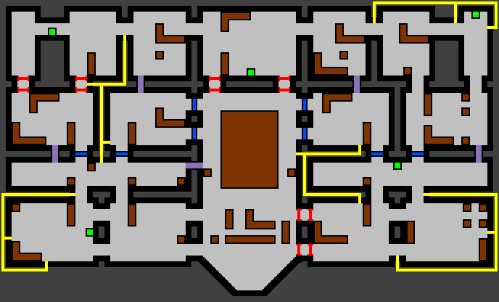

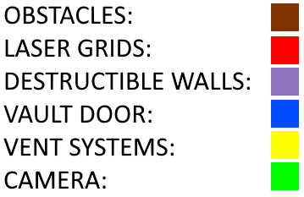

## Tutorial Level

### Physical description

Designed with new players in mind, this level or series of small levels will be crafted to guide them in using the different abilities against some basic AI opponents.

Lessons to be taught would be:

* How vision works
* How sound travels
* How to interact with the environment
* How not to be seen, via evasion, hiding or camouflage,
* How not to be heard
* How to use class/team abilities
* etc.

### Map layout examples

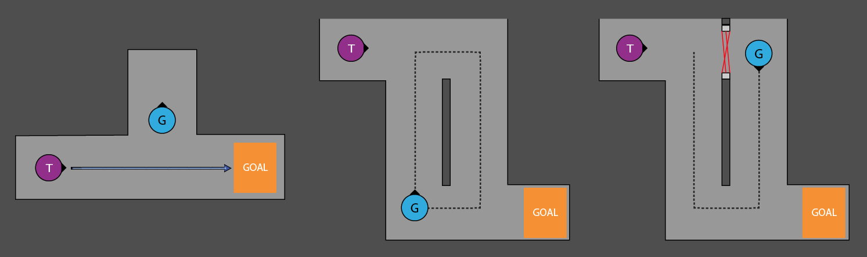

# Interface

## Controls

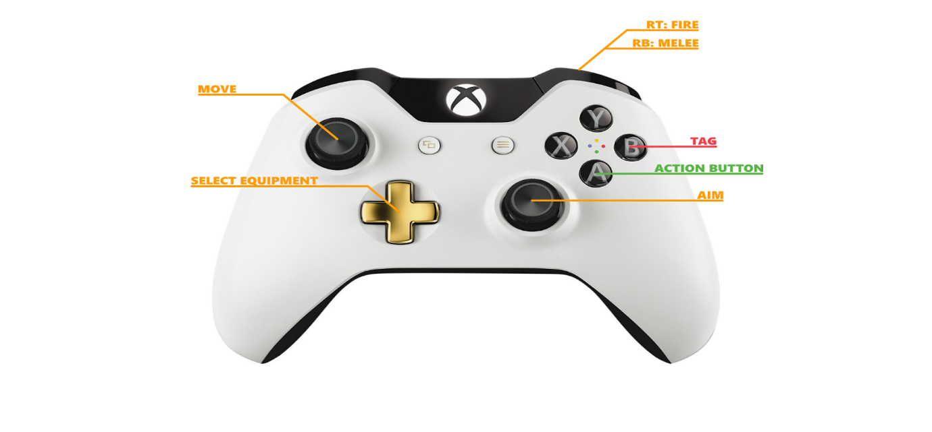

|  |  |
| --- | --- |
| https://lh4.googleusercontent.com/Nk8MbiF9SropHbDuToOln_k8y_lvYo5Uz3RV-Oj5BZhjynPvJyqWy-dxXT7apR1zS2GoDixgIDlKylcvFbuqY8bhocrSaaIbjT7Aps9vi1Ga67sXwQS_1p8RwuR8pf1zEd8NK4gO | Action button. Activates environmental mechanics. Prompt appears on-screen on player approach. |
| https://lh4.googleusercontent.com/AujW5UuN4fa7QRV9AdU7VKyBgbh0rlPEhkAyeeJvmwh7RY2pIW9ifM5FKAO7YMtstlNhkyUk2ptlG13M-C9uwqgPLgziPe97IQlat0G60P9SwEo_sg8gklxRrrU85wH3-xJOHWeu | Tag button. Allows players to tag parts of the screen to communicate with teammates. Move tag selector with the Left stick. |
| https://lh5.googleusercontent.com/Jep7x_SB4ScdeJWipn42CimRd6VL8O6P3jv7PSgPPAEvvgq7Z-U2YmVZVGPT51vwOYcOjNjhCFy8mCKEnl2d0hANCsEvzbMCmKiFk0t4RboiKwjLHcJB0zOtNuEe1N2pR5oO6cD2 | Move player character. By default the player moves at a stalking pace, but used in conjunction with LT elevates the pace to a run. Running draws attention by making a lot of sound, so it is ill advised. |
| https://lh3.googleusercontent.com/Zv1TX3ddRJD_wcMANLnf_GwUkcwdrEZqruFt9mSY21-mMQvHQCNUQwWj6RNFW_-sE9F-ti0uB1ydHdkaFSkxE4xWepdaQxFz1Mg9WP6an5MslH92g0I7-7B2LnQSxHhFEUjvWpno | Allows players to aim. Points the crosshair at the corresponding angle around the player character. |
| https://lh6.googleusercontent.com/6QGs1pfn2i25lXo465kra0LfF2__ZTvsWEVlM1Q8uswFcmvcR3l-y1H5hZ-FmkfTv23lYm_VRp7g3GoXVp0vc4LfWD6kZM4LgPPzPK2ljtOMs1hA_rLYpLMyHSME484ElA5XGWTG | Select equipment / abilities. Allows players to cycle through their arsenal and select the appropriate item. |
| https://lh4.googleusercontent.com/8VzEYbaC9fu9yZlZuq7wYeqHdX5Ss_YfHoXPWegd2HM2VY2zhe4w3F0Wi8fZVcviV-RksxayEDgw2oQ1R7wMlta_Gj6LzRQpIWmEmABy9YRCq7bOvmNIYv4vsmakVaCZQrulexhY | Executes a melee attack, stunning any enemy player in the immediate vicinity. |
| https://lh5.googleusercontent.com/qJ3GyDWSZRAYWT-15a9vB-fUvsTMeJyi5vrnbH2qSFVwp-6mEzxzmMRoByT7L5rCXbqdAqCvvOLzxwbrcMCQAJQiQIVGraigtbMoOqkOimowU8DfcP2KkBDOoncYBBYWpZPRERJ4 | Fires the player’s weapon. |

## Visual Interface

### HUD

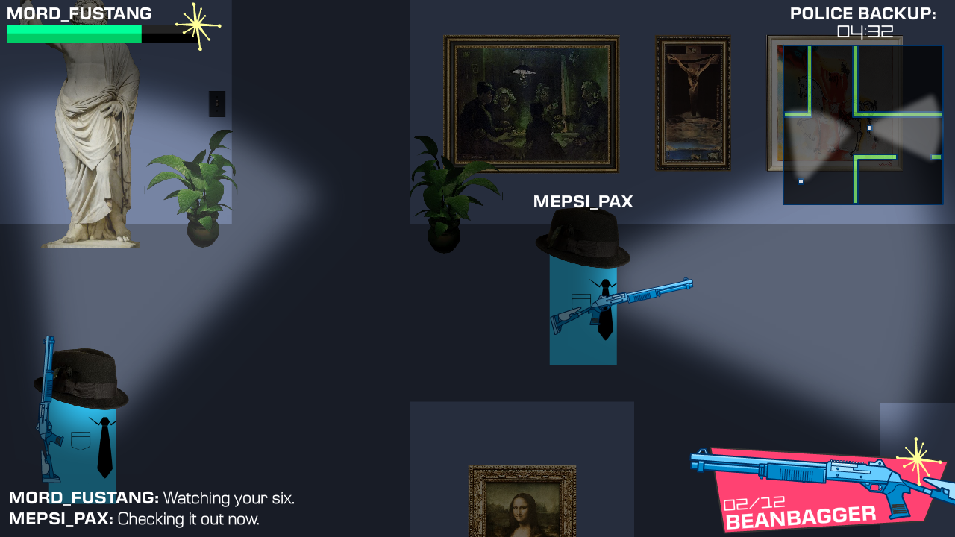

**1. Fog of War**

The fog of war shrouds the game world. It masks enemy types, numbers and movement, heightening the tension and providing an incentive to explore the game world carefully. This means that players must rely on incomplete information as they approach and avoid the enemy. Players have to improvise based on intuition and common sense. Communicating effectively with teammates is the key to overcome the lack of information presented to each individual player.

**2. Stamina Gauge**

The stamina gauge allows players to see how much energy they have. Running and melee attacks drain stamina, and without stamina, players cannot use these abilities. This means that they must use their abilities in moderation.

**3. Timer**

The timer counts down until the end of the round. In the context of the game world, it is the time remaining until the police arrive to arrest the thieves. If the timer reaches 0 before the thieves are able to steal the artwork, the guard team wins. This makes it an extremely important part of the game, so it needs to be on the screen at all times.

**4. Radar**

The radar shows where teammates are on the map and highlights areas of attention. It directs players to important areas of the map - areas of loud noise are highlighted allowing players to avoid or approach threats.

**5. Equipment**

This allows players to see their equipped gear and the stats relevant to their use - pictured is the “Beanbagger” shotgun, which allows guards to take down thieves non-lethally. It has a limited ammo count, displayed as the number of rounds in the chamber and the total number of rounds remaining. Other equipment, such as the Taser, recharges over time, so its “ammunition” will be represented with a regenerating bar.

**6. Communications Log**

The communications log allows players of the same team to communicate through the in-game messages and tagging feature. This will allow distant players to communicate and cooperate tactically.

**7. Player Name Tag**Online players will have their name tag above their head to help differentiate between them.

### Menus

**TITLE SCREEN**

Display’s the game’s title and awaits player input, bringing them to the main menu.

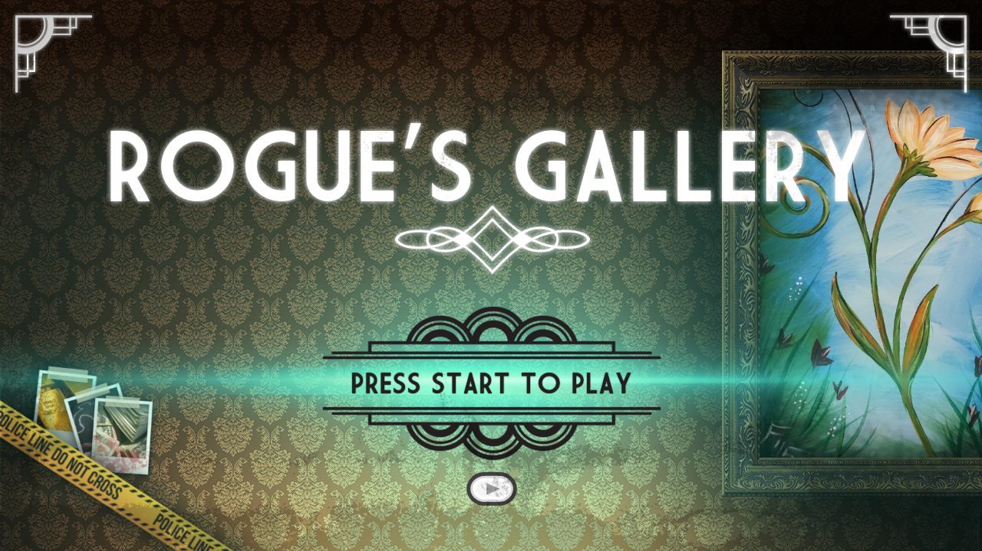

**MAIN MENU**

The starting point of the application, providing access to the game’s features and its settings. Also allows players to exit the application. Friends who are online will be displayed on the main menu, providing a quick and easy way to set up or join their games from the start of the application.



**OPTIONS**

The options screen will allow users to adjust the game’s technical and graphical settings.

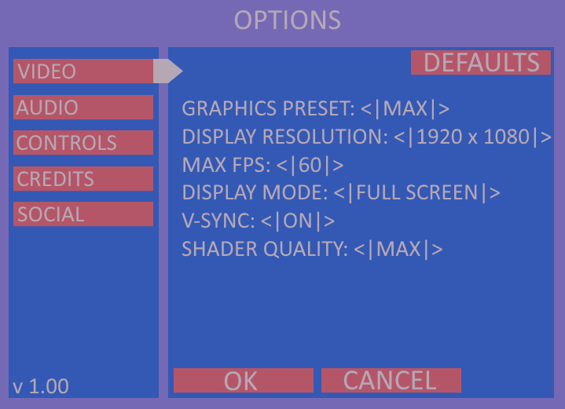

**MATCHMAKING LOBBY**

The lobby will let players set up or join existing games, displaying what players you have connected with and displaying relevant information to the current game. It will give players a short break between games to inspect the upcoming match, discuss and examine the last match, adjust the game’s settings and communicate with other players.

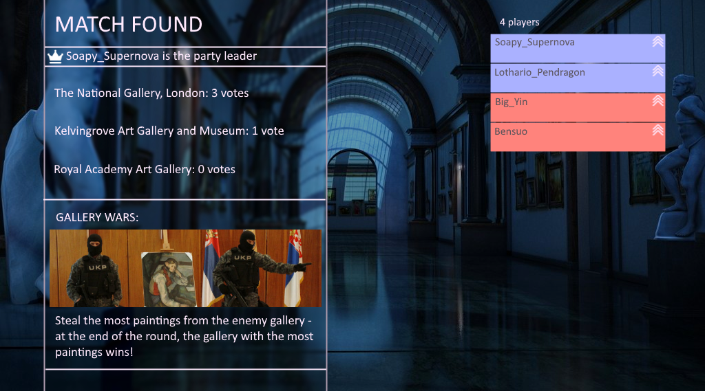

**CHARACTER SELECT**

Allows players to select their character, and by extension, the abilities and equipment they will be able to access in-game. Will display character bios alongside their statistics and gameplay information.

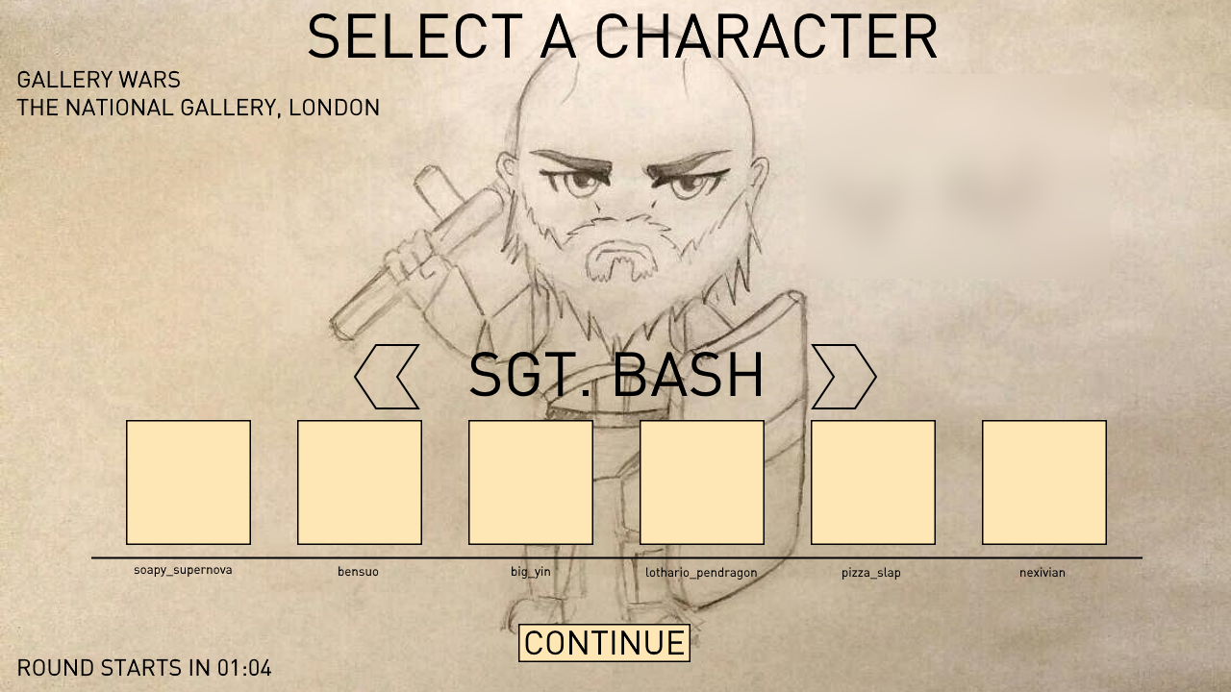

# Art

## Style

We will pursue a cartoon-like, retrofuturistic aesthetic influenced by atomic-age art and classic crime-fiction. While light-hearted in tone, the aesthetic will evoke an age punctuated by excess, technological advancement and suspense; when Cold War fears were at their peak and audiences longed for excitement and espionage.

## Influences

A pastiche of western graphical design, environments will feature a “Raygun Gothic” style, lifting motifs from Googie architecture, Streamline Moderne and Art Deco.

This will give our environments an open, classy and futuristic shine while tapping into that atomic-age graphical style.

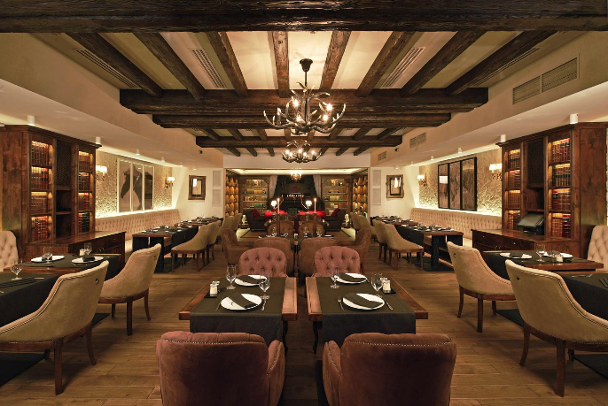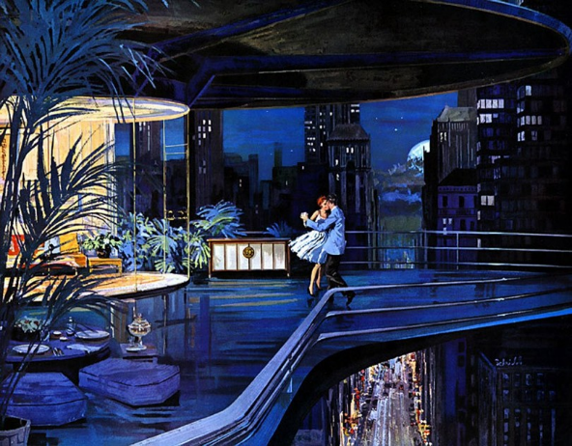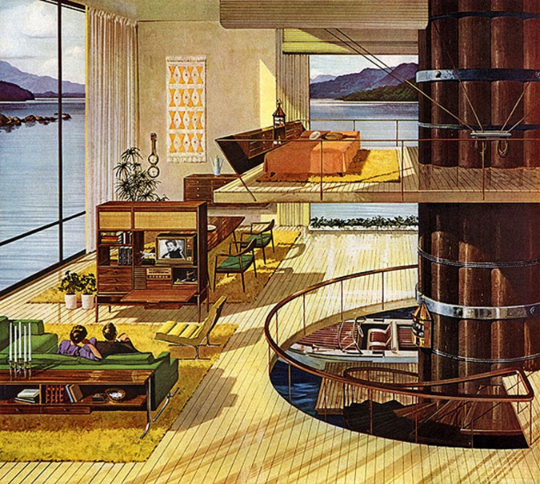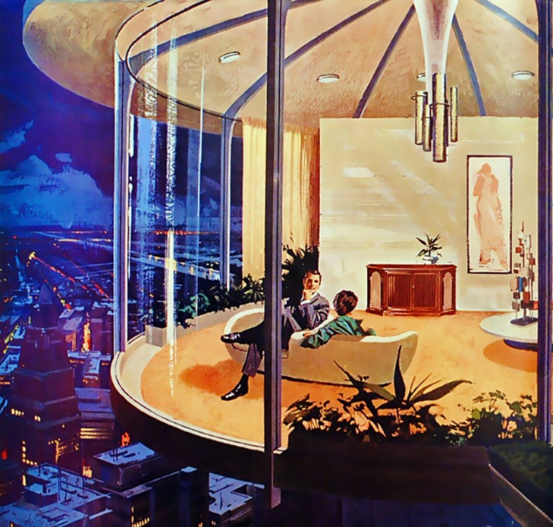

Character designs will borrow heavily from Film Noir, Hardboiled pulp-fiction novels and Cold War-era spy movies.

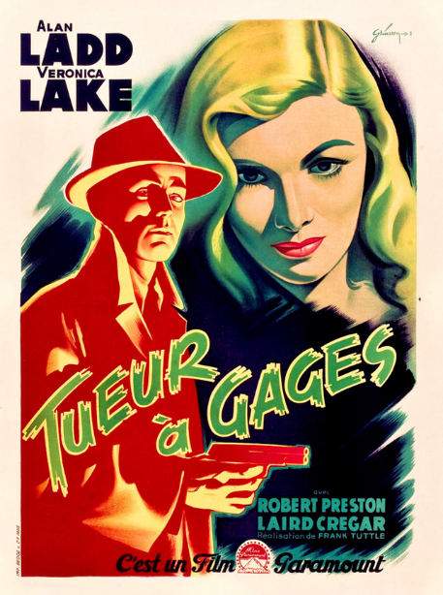

The men are burly, rough around the edges - they ooze masculinity. The women are sleek, sexy and dangerous. The cast of our game should reflect these tropes and use them to contextualise the gameplay - the all-female thief team are catlike and sneaky, while the all-male guard team are unrelenting and hard.

Visuals will be vibrant and distinct in shape, with strong colours and shapes evocative of Saul Bass’ film posters. UI elements will lift directly from his geometric paper-cut style.

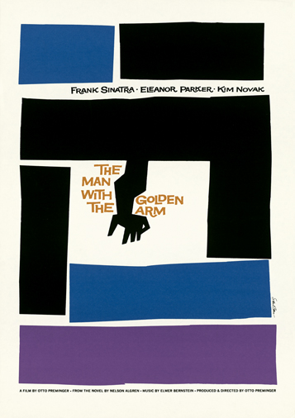

## Concept Art

**Sarge / Sgt Bash** **Swat Guy / Marlowe Smoke Bomb Girl / Misty**

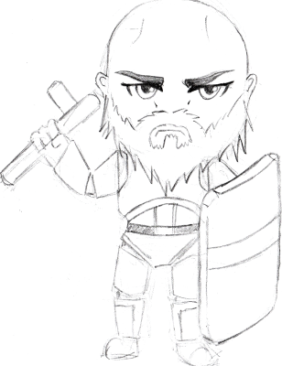 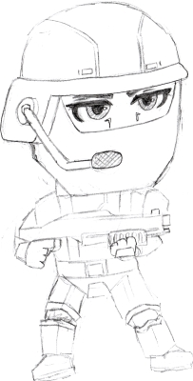 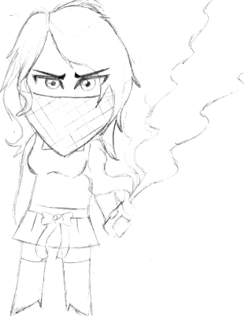

**Chameleon Girl / Leona Escape Artist / Harriet Saboteur / Ratchet**

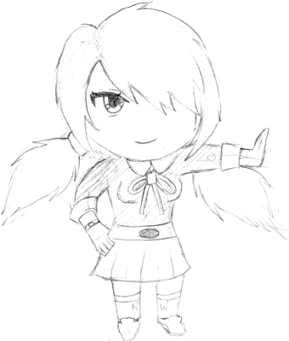 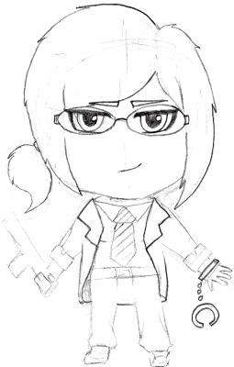 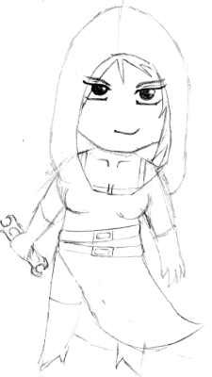

# Audio

## Music

The game’s score will feature Jazz and Surf-Rock-inspired music, marrying modern heist soundtracks - such as the *Ocean's* series - with classic 60s movie scores - such as *Dr. No*. These styles and inspirations will support the crime-fiction aesthetic; a modern, tense score flavoured with classic film tropes and motifs. As such, it will evoke cliché elements from 40s - 60s cinema in the sound, like big-band horn sections, heavily swung jazz drums and surf-rock guitar.

For tense incidental music with surf-rock inspirations, we will look to the early James Bond scores, such as *Dr. No* and *Goldfinger* for inspiration. The use of surf-rock guitar on Dr. No heavily influenced the spy-film soundtracks of the 60s, so tapping into that inspiration will help our music sound more authentic. For jazz inspiration, we will look to Yoko Kanno’s *Cowboy Bebop* soundtrack, which features a colourful pastiche of big-band jazz, swing and blues music. Games with a similar musical direction include *Team Fortress 2, Gunpoint* and *Metal Gear Solid 3: Snake Eater.*

Incidental music will range from ambient jazz-flavoured tracks for sneaking to full blown big-band atonality for combat and panic. This style of music will tie the soundtrack to the aesthetic and the setting, making the game a complete Cold-War era heist experience. This colourful, expressive sound will set our game apart from other multiplayer indie titles on the market.

## Voice Work

Our game will feature voice work for each of the player characters, who will feature voice lines that allow players to communicate in-game. We would like a diverse voice cast that can express the characters different personalities.

## Sound Effects

The game will need to feature a large library of sound effects. Sound is an integral and often-overlooked part of the gameplay experience. In our game, silence is a huge gameplay advantage, so we need to carefully consider how to handle sound - and the lack of it.  
As the players sneak through the gallery, general room ambience will be audible. The weather outside - rain and thunder. This will help build tension and create a point of reference for the lowest level of sound. Moving quickly will produce audible, reverberated footsteps which will draw attention to player’s positions.

# Technical Design Document

## Target Hardware

Target platforms for the game will be PC, Mac and Linux.

### Minimum Hardware Requirements

OS: Windows 7 or later/Mac OS X/ Ubuntu/Debian Linux  
Processor: 1GHz processor or better  
Graphics: OpenGL 3.0 capable GPU  
RAM: 2GB

As the game is 2D the system requirements will likely be fairly low. This minimum estimate is based off what is required to run Monogame, however a more accurate estimation of minimum specifications will require testing late into development of the game on some older hardware or virtual machines.

## Development Hardware and Software

### Hardware

The team are already able to supply their own development PCs providing they meet the minimum requirements for at least running Visual Studio or any other software required. These are:

* 1.6 GHz or faster processor.
* 1 GB of RAM (1.5 GB if running on a virtual machine)
* GB of available hard disk space.
* 5400 RPM hard disk drive.
* DirectX 9-capable video card that runs at 1024 x 768 or higher display resolution.

### Software

The following is a list of software we will be using during development of the game:

|  |  |  |
| --- | --- | --- |
| **Development Area** | **Name** | **Details** |
| Programming | Visual Studio Community 2015 | IDE for use in developing on Windows machines, the obvious choice for working in C# with great debugging tools. |
|  | MonoDevelop | IDE for use in developing/testing/building on Mac and Linux machines, ideally suited for use with Monogame/Mono. |
|  | Git/GitHub | Version control software and online cloud storage used to maintain a central codebase and allow multiple programmers to work on it in tandem. |
| Art | Adobe Animate | Primary application for drawing art assets/animating sprites |
|  | Adobe Photoshop | Industry standard raster image editing software |
| Audio | Reaper | Multitrack DAW (Digital Audio Workstation), cheap licenses and powerful capabilities for producing sound effects as well as music. |
|  | FL Studio | Multitrack DAW, more focused on creation of electronic music assets. |

## Development procedures and standards

Establishing a set of procedures and conventions for developing the game is important in making the code easy to read and understand for our programmers and keeping the project organised.

### Coding Standards

**Naming Conventions**

* Methods - PascalCase method names, short but descriptive camelCase parameters, e.g.
  + Void HandleInput(KeyboardState currentKeys, GamepadState currentPad)
* Classes, public member variables - PascalCase
* Private member variables - camelCase with “m-” prefix, e.g mScreenList, mCurrentKeys

**Best Practices**

* Any code that’s function is not immediately obvious requires a short comment, methods require a one line comment explaining basic function.
* Use these special tags for comments:
  + “TODO: “ used for areas of code which have not yet been implemented, must include a brief note of what is to be done.
  + “TEMP: “ used for code which is to be re-done later due to sloppiness, inefficiency etc.
* Global variables/Static classes should be avoided as much as possible.
* Prefer composition over inheritance, inheritance should only be used where necessary or where the code can take sufficient advantage of polymorphism.
* Descriptive but not overly lengthy class, variable and method names.

**File Structures**

The project folder should be organised as follows:

* TOP LEVEL PROJECT FOLDER
  + Assets
    - Graphics
      * Characters
      * Maps
      * Menus
    - Audio
      * Music
      * Sound Effects
    - Data
      * Maps

Subfolders created in this structure should be simple and descriptive using PascalCase and organised in an appropriate way. For example, creating subfolders in Assets/Graphics/Characters such as “Character1”, “RobotGirl” etc.

### Source Control

The following procedures should be followed when it comes to version control:

* No working in the master branch.
* New feature = new branch, this makes life easier should rollbacks be required.
* Pull requests must be approved by Programming Lead.
* Commit often, with appropriate names and descriptions of changes made.
* Avoid multiple people working on the same code areas at once as much as possible to minimise merge conflicts, within reason.

## Game Engine

|  |  |  |
| --- | --- | --- |
| **Name** | **Pros** | **Cons** |
| Unity | * Fully featured engine * Makes use of C# * Widely supported list of platforms | * Requires pro license to remove “Made with Unity” screen * More suited for 3D games |
| Unreal Engine | * Free (licensing fees apply after a certain amount of sales) * Fully featured engine * Visual scripting features * Widely supported list of platforms | * More suited for 3D games * Overkill for our needs * Programming requires C++ |
| Monogame | * Uses C# * Lightweight framework suited for 2D games * Team is experienced with it * Widely supported list of platforms* | * Framework requires more work initially to get the game going * * Supported on console platforms but access to these libraries may be limited by being registered developers for those platforms. |

After examining some other common options we’ve decided to develop the game using Monogame. It is a lightweight framework ideally suited for 2D games, our team is already very experienced with it as well as C# and it supports a large number of platforms (including current gen consoles through dev programs if we want to pursue those platforms in the future). As we are focusing on PC platforms first this should be no issue, if the initial release is successful we will be in a good position to pursue the development programs for consoles and access the Monogame libraries for those platforms.

Other engines such as Unreal or Unity would no doubt work for our needs but as listed above they are geared more towards 3D games (although they do have support for working in 2D). The lighter framework option gives us more control over development and avoid bloat with extraneous engine features. Couple that with the team’s lack of experience with other engines and Monogame becomes the obvious choice in this instance.

## External Libraries

### Wwise

Sound is an important part of creating a game and in this area Monogame lacks a comprehensive out of the box toolkit. We will be using Wwise as a middleware solution for all the audio in the game, giving us a number of advantages:

* Rolling our own solution would take a large amount of time or be very basic in function.
* Wwise is widely used in the industry with plenty of material available for our team to quickly learn to use it.
* Gives us access to features like full mixing and sound processing capabilities, dynamic music implementation etc.
* C# bindings are already available (here: <https://code.google.com/archive/p/wwisesharp/>) under the LGPL license allowing, again saving us from creating our own bindings.

## Networking

Monogame includes the Lidgren Networking Library (<https://code.google.com/archive/p/lidgren-network-gen3/>).

The game will utilise a peer-to-peer networking model with one player acting as the host/server and the other players connecting to them as clients. This removes the costs and technical issues present with maintaining dedicated servers and the game does not require the high power servers that for instance a first person shooter would.

The server model used will be authoritative meaning that the server runs all the game logic for a match and has final say over each client’s position etc. The clients will send inputs to the server and receive the updated simulation data for all clients from the server. In addition the clients will perform some client-side prediction of some game elements to improve the game’s perceived responsiveness/compensate for ping lag, and perform corrections based on updates received from the server as necessary.

## Graphics

### Characters

Character animations in the game will make use of sprite sheets. Individual animations will be contained in an “Animation” class object which contains data such as: frame size, number of frames and position on the sprite sheet. A collection of Animation objects is held in an instance of the “AnimatedSprite” class, containing all of the individual animations for one character or object and controlling their playback, display etc.

A single animation must be contained within a single sprite sheet however a single AnimatedSprite can contain animations from multiple sprite sheets. Given Monogame’s maximum texture size of 4096x4096 pixels this gives a reasonable amount of space for large single animations in one sheet but gives us the flexibility to spread character animations over multiple sheets rather than be confined to one.

### Maps

Maps will use a tiled format which provides several benefits - it simplifies the design process and allows for easier iteration on map designs; we can make use of existing tile map editors/formats instead of rolling our own; tile sets let us reuse art assets in different map configurations easily to increase map variety.

A single map tile will be 96x96 pixels which at 1080p resolution displays 20 tiles horizontally and just over 11 tiles vertically. This also means that a single 4096x4096 tile sheet could hold upwards of 1700 individual tiles.

The game will make use of the Monogame.Extended library which supports loading of TMX map formats from the Tiled editor for ease of use and loading.

## Code Overview

### Main Loop

The game’s main loop will be fairly simple delegating main updates and drawing functions to objects such as the screen manager. In this way we create a more encapsulated and readable code at the cost of a minor amount of complexity (splitting code up among classes).

The main game loop will follow this structure:  
  
Beginning of the loop.  
 Check for and handle incoming network information.  
 Handle the local player’s input.  
 Update the player and other entities movement.  
 Check for collision between the local player and other game objects.  
 Collect and send outgoing network information.  
End of the loop.

### ScreenManager

The screen manager’s function is creating and maintain the different screens within the game and controlling their drawing/updating. For example main menus, game screens that run the actual gameplay code, pause screens. The class with utilise a stack based system allowing screens to be overlayed on top of each but for example allowing only the top screen to receive input/updates.

### Screens

Screens will make use of inheritance to allow them to be easily managed by the ScreenManager using Polymorphism. This works because all screens work in much the same way, they receive input from the controller/keyboard, they update themselves and they draw themselves to the screen.



### Animation

An animation object contains the following data:

* The number of frames in the animation
* The number of frames per row of the animation.
* The frame size (width and height) of each frame, this is the same across the whole animation.
* The starting position of the animation on the sprite sheet (x and y).
* The length of the animation in milliseconds.
* An index for which sprite sheet it uses (this is used by the AnimatedSprite class).
* The current time of the animation playback.

When an animation is called to draw itself it programmatically works out which frame it is on given the number of the frames in the animation the length of the animation and the current time of playback. It then uses this value and the initial frame position, width and height of the frame and number of frames per row to work out which part of the sprite sheet to display. This generates a rectangle which is passed to the Monogame drawing function which draws only the part of the sprite sheet which is indicated by the rectangle object.

### AnimatedSprite

The primary function of the AnimatedSprite class is to maintain a list of different animations, control their updating and playback etc. Each object such as a player or enemy which requires an animated sprite will contain one instance of this class. It contains the following data:

* A list of Animations.
* A list of sprite sheets.



## File Formats

* Audio - Music will be in MP3 format at 320kbps bitrate, Sound Effects must be in WAV format with 44.1khz sample rate and 16-bit depth.
* Graphics - All graphics must be in PNG format which a maximum single image size of 4096x4096 pixels.
* Maps - Maps will use the TMX file format used by the Tiled map editor.

# Business Analysis

## Market Research

In order to gauge the potential for success of our game design we have performed some market research through a small questionnaire to consumers, and investigating game titles that have already been released via websites such as SteamSpy and Metacritic.

The information gathered will be used to assess and justify our development budget and the eventual pricing of the game.

### Questionnaire and results.

The data collected is from the questionnaire is of a small enough sample size to limit our ability to do any further breakdowns by gender etc., but we feel it is sufficiently representative of our target audience to make some general assumptions of how well our future users may respond on playing the game.

The attached sample form [see appendices] shows what we presented. Three sections, Demographic information, opinions on aspects of multiplayer, and opinions on aspects of asymmetry. We received a total of 36 respondents, from an estimated delivery to 300+ people from our own as well as other university classes, and family and friends via social media.

#### Respondent Demographics

Of our 36 respondents:

78% were male, 22% female

89% play games on the PC

64% identified as Core, 19% as Hardcore 17% as Casual gamers

83% played multiplayer games, and 83% played asymmetric games

53% spent at least 30 minutes gaming 6-7 days per week, and all gamed on at least 2-3 days per week

From this we can see that the bulk of the responses are representative of our target audience (as described in section 1.5), more so when you include the potential audience in Hardcore gamers. As we only have a single female Casual gamer, compared to 5 male, we do not feel that a gender breakdown will provide any further useful information.

#### Multiplayer

For this section we asked respondents how strongly they agreed or disagreed with statements related to the multiplayer experience on a range of 1 (Strongly Disagree) to 5 (Strongly Agree). By taking the average normalised value of all the responses to the statements, we can see how positively they view these aspects as players, and where strong consensus is shown how important it is to the players.

The graph below shows a summary of the individual questions and responses:

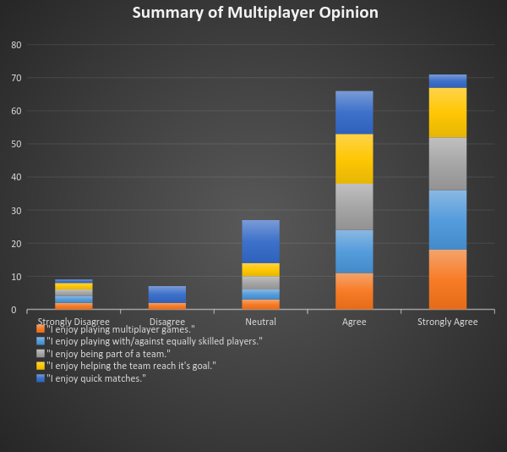

The graph shows a strong agreement in all aspects of good multiplayer experiences, the consensus heavily supports our design choices regarding the team needing to work together and players being dependent on each other for a good chance of success. The main item that divides our players is the length of matches though it still remains positive on the whole. Though match length will be heavily dependent on how well each team’s abilities are tuned, the size of the maps, and a number of other factors that will be best investigated and tuned during prototyping and development.

#### Asymmetry

For this section we asked respondents how strongly they agreed or disagreed with statements related to the multiplayer experience on a range of 1 (Strongly Disagree) to 5 (Strongly Agree). By taking the average normalised value of all the responses to the statements, we can see how positively they view these aspects as players, and where strong consensus is shown how important it is to the players.

The graph below shows a summary of the individual questions and responses:

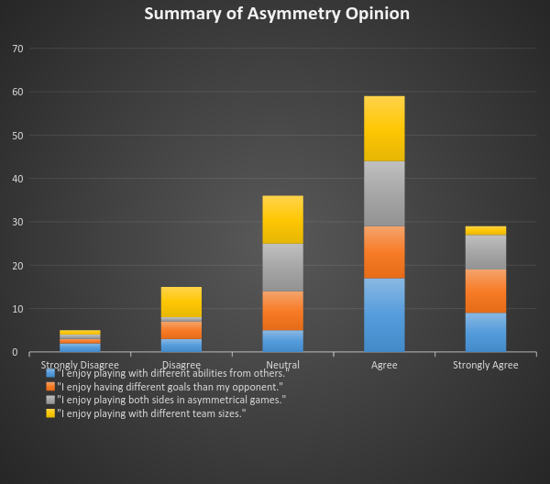

The graphs shows a positive yet not strongly held opinion of asymmetry in games giving us confidence that we can receive a positive first impression with our core audience. Different team sizes show the largest amount of negative feedback, but overall it still balances to slightly more than neutral, and is an aspect of asymmetry that we will not be including in our design and now know that it should be better received without this. The lower overall strength of opinion shown here also tells us that while we can use asymmetry in our design, having the teams be too dissimilar in their goals and abilities will have to be carefully balanced and play tested to ensure the game feels fair no matter which team you’re currently playing in.

#### Conclusion

The respondents are a very good reflection of our target audience, and provide opinions which support our multiplayer strongly and asymmetric positively yet cautiously. Overall, we feel this is a good indicator for our design, and with some alpha playtesting early in development, we should be able to gauge player opinion and determine any changes to the degree of asymmetry should they be required.

### Analysis of Similar Games

Information on exact sales figures in the PC marketplace for independent titles is rare, as such what can be found from other sources can be inaccurate or unreliable. To help alleviate the impact this might have on our conclusions we have looked at a number of titles we feel have a thematic or mechanical similarity to our design, hoping to estimate the size of the potential market for our game. To date we have found no one game that holds a strong resemblance to our design in both theme and specifically mechanics and implementation.

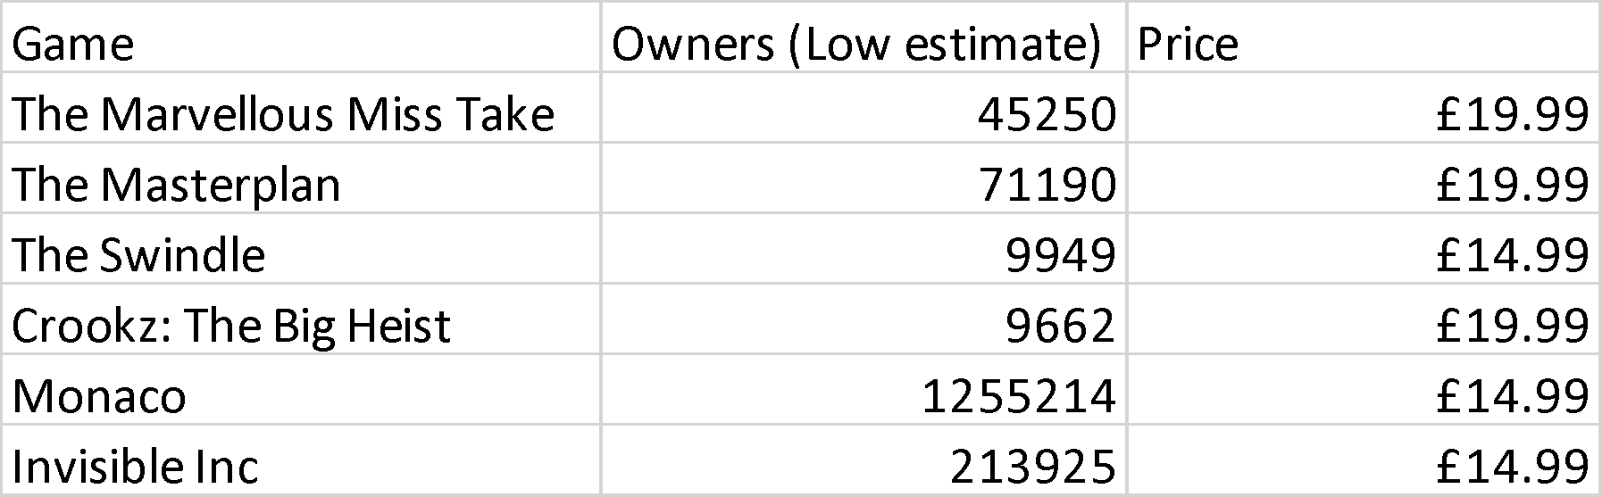

From the table above you can see a number of titles we feel hold thematic or mechanical similarities. The strongest comparisons for real time mechanics and game theme are The Marvellous Miss Take, The Masterplan and Monaco, (showing strong sales at a higher than average price point for indie developed titles), with The Swindle, Crookz: The Big Heist and Invisible Inc sharing the theme more than mechanics.

The Marvellous Miss Take shares some of the vision and hearing mechanics that we will be looking to implement, the theme of an art thief in a gallery avoiding the guards and other security systems, I think would be a good imagining of our game experience as an individual might perceive it (with its randomised guard patterns simulating other players). It’s also on the lower end of the sales figures, with approximately 45,000 units.

Given the lack of multiplayer experiences that have strong similarities to our design, and the strength of sales in this area of the market, we feel we can make an impact with our title without great risk of direct competition.

## Pricing and Sales Platforms

### Cost of Development

When considering pricing we have to consider overall development costs involved in our game.

#### Staffing Costs

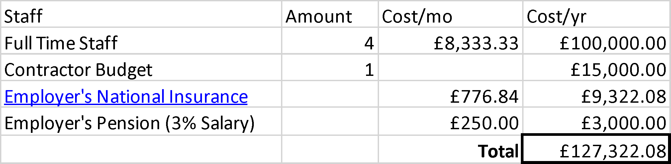

The current team of 4 developers will be working in an even share of workload and responsibilities, reflected in an even distribution of salaries at £25,000 per year. Between the current team members we are confident we can perform most of the tasks required to bring a quality product to market, with our weakness being in the production of art assets. As such, we would be assigning a fifth sum of £15,000 to either hire an artist for a portion of development, or to source our assets from a contracted third party company.

This gives us a potential staffing cost of £127,322.08 over a year of development.

#### Equipment Costs

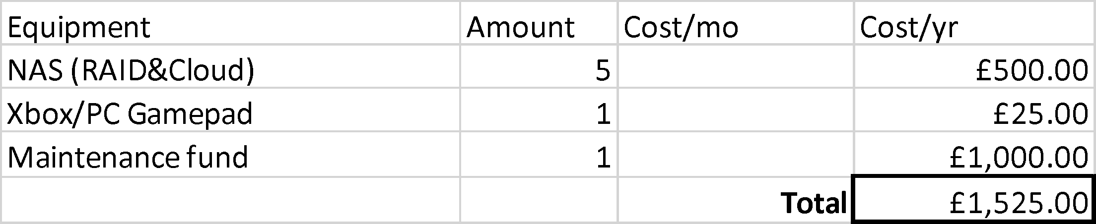

Currently our team are equipped with PCs that are more than capable of running our development environments, though these machines are our personal belongings and could be subject to unforeseeable problems during development due to their configuration. Using these computers will give us a good array of hardware to ensure the game runs optimally across different systems however, acting as a micro test environment.

So long as we as a company can assist in the replacement of any failing parts during development, the only real initial worry is redundant storage to ensure no data loss. To this end, it is proposed that we build and provide a NAS to each member of the team, which can be constructed with ample storage for around £100 per unit, with 5 in total should we hire an artist or require a replacement.

A team member does not have a suitable gamepad to assist in game testing, this will cost £25.

A maintenance fund in case of emergencies of £1,000 would allow us to develop risk free and adapt as required to any problems that may occur.

This brings our total equipment costs to: £1,525.

#### Software Costs

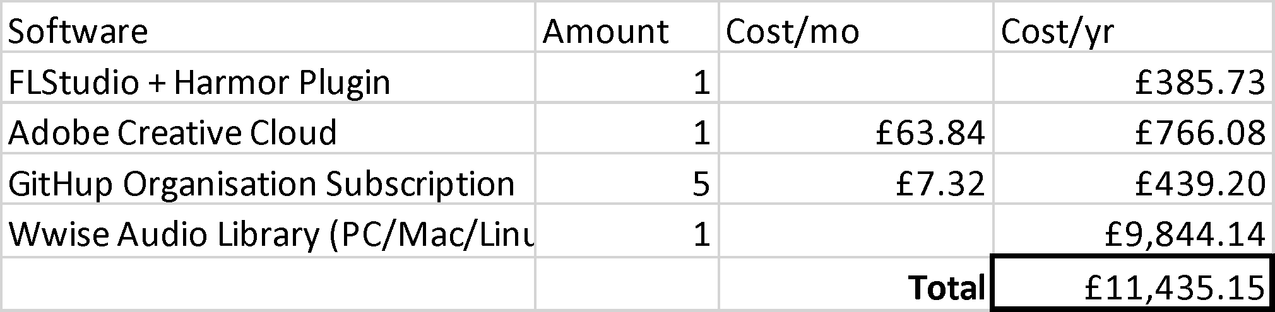

As we will be producing as much of our assets in house as possible, FLStudio and Adobe Creative Cloud are required.

GitHub Organisation subscriptions for all team members gives us source control in a centralised cloud environment with the addition of granular access rights, a necessity when working with external contractors and third parties.

Our largest expense by far is the WWise Audio Library, this is a single one time purchase and can also be traded for a 1% of gross income from the game. This cost does not need to be decided upon until the end of development, though it is at the provider’s discretion whether they will waive the 1% gross if we take that as our initial license type. I’ve selected the fixed price as it does not incur ongoing costs or management overheads after release.

#### Other Service Costs

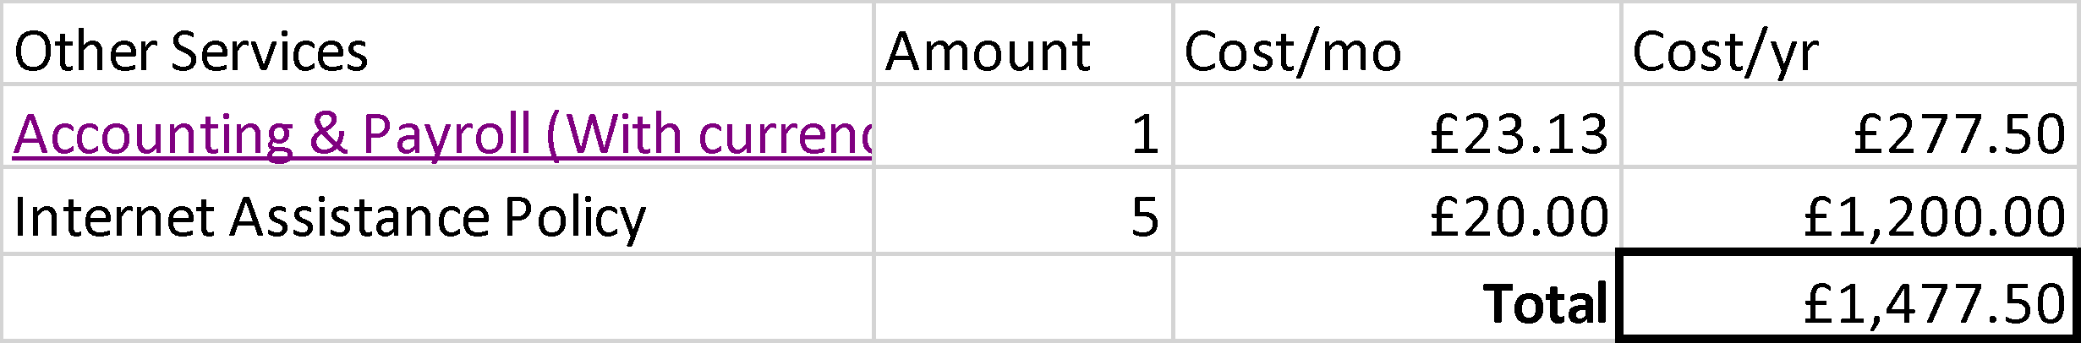

Accounting and payroll are required to ensure smooth running of any business, the service I have found offers accounts checking on the go, staff holiday management and management of personal information by individuals themselves. After initial setup, this should reduce the burden of work on any one individual on the team, allowing us to focus on developing the game. At the end of year, the service can produce our end of year account automatically, important for determining how much tax we are liable to pay or have discounted via the VGTR.

As each team member will be working from home, they each will be provided with an allowance to cover their internet provider costs on a pro-rata basis, determined by their logged work hours per month, to a maximum of £20 per month per staff member. This gives us a maximum cost of £1,200 in internet fees.

This gives a services cost of £1,477.50 over the year of development.

#### Other Costs

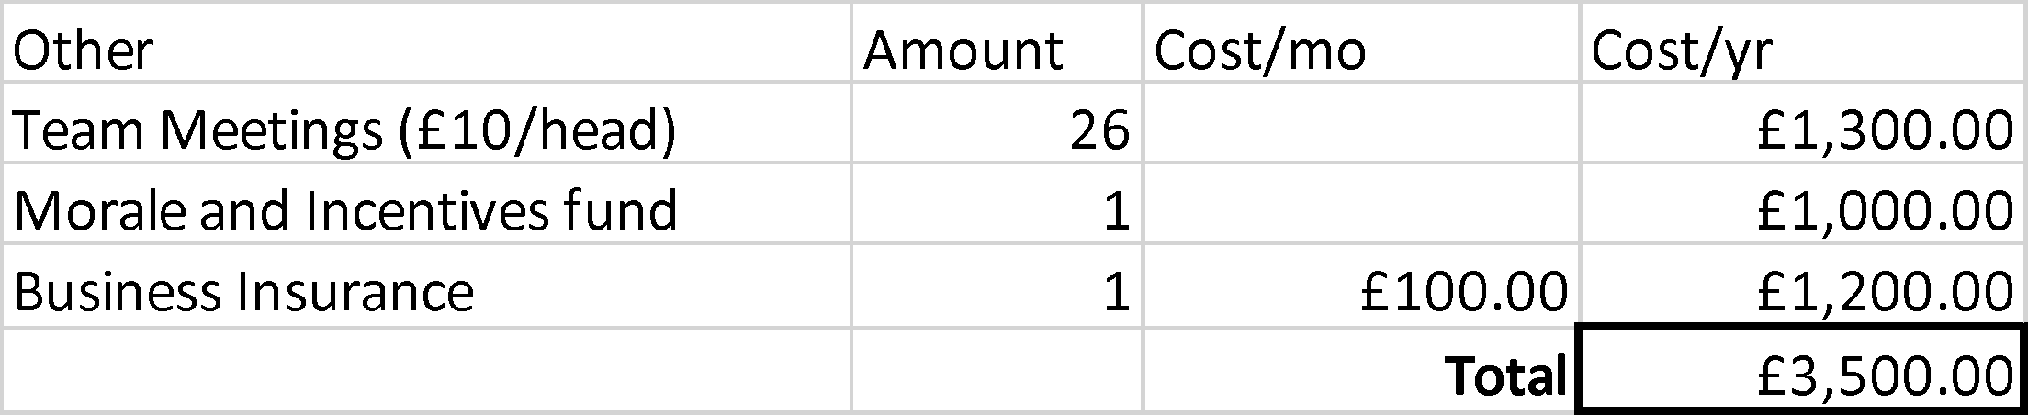

Team meetings are expected to be held at the end of each sprint, with each team member being expected to attend in person for first the formal progress reports, then informal team bonding. It’s important that everyone attend these meetings where possible, therefore we plan to have a small catering budget to get everyone a sandwich and tea or something similar. Given up to 5 team members, 26 two week sprints in a year, and £10 per head on a reasonable lunch deal, we get a cost of £1300.

Team morale is important, and rewarding the team for reaching development milestones is a good way to show this. The ability to reward the team on successful completion of milestones is best made through both team incentives like a celebratory night out, or through individually targeted gifts based on the performance and needs of each staff member. A discretionary fund of £1000 would more than be suitable to allow for incentives throughout the year, and a suitable launch party at the end of development.

Business insurance will include our professional indemnity cover as well as employer’s insurance. We have sought quotes from various sources but as we are a game developer, insurers are not all currently providing the type of cover we require. In lieu of an accurate quote for the time being I have estimated a reasonable cost for a small business of our size, though this will be subject to change on commencement of the project.

Our total for these costs is £3,500.

#### Marketing Costs

Marketing the game can begin early in development once we have some solid visuals and artwork, though as time goes on we will likely need to hire an experienced marketing company to promote our game the right way to ensure a successful launch, especially with a multiplayer game.

Knowing that if we keep steady updates to our community, manage it properly, and cultivate our own set of advertisers and evangelists, we should be able to reduce the requirements for hiring a third party until the final months of development when we’ll need to make a hard push for coverage in a large amount of places to get us the splash we need when our game lands on the digital storefronts.

We are assigning £20,000 as a marketing budget. This can be revised, though we feel it should more than cover our needs.

#### Total Costs

All of the discussed costs come to a total of £165,259.73, with minimal expectation of deviation by end of development.

### Platform Costs

Releasing through most digital storefronts will incur around a 30% cut in gross takings on all sales including DLC and in game purchases. The Apple App Store on iOS and Google Play Store on Android are confirmed with this percentage, and wide agreement though no confirmed sources due to developer NDAs for the Steam marketplace show this to be the most likely cost to expect should we release in this manner.

Releasing on PC is going to incur it no matter where we deploy unless we arrange for distribution from our own website. This wouldn’t be recommended due to technical and security requirements for such a storefront to operate reliably and safely, but also as we’d be missing out on already established player bases (with the friend and community integration), the globally capable and robust product delivery and support systems, and (in some storefronts) further assistance with marketing and pricing among other developer focused support.

The costs of release when releasing in a digital storefront via PC vary from store to store, but the size of the user base, services for third party developers, and overall flexibility provided by Valve’s Steam store are second to none. Through a Steam release we would have the ability to sell via a number of other storefronts and our own website, providing Steam Keys to be redeemed in the Steam Desktop Client.

### Pricing

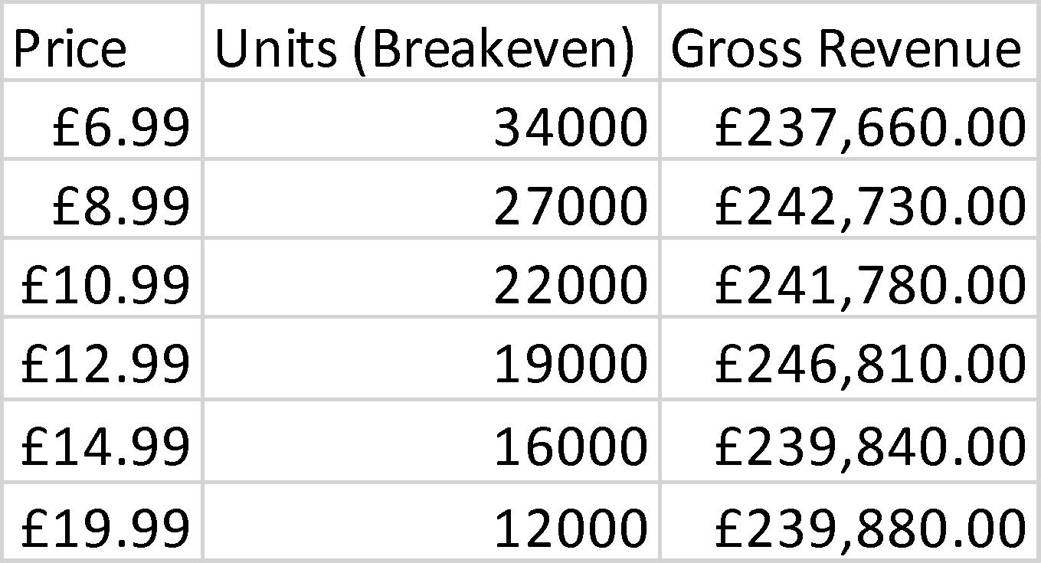

From the table above you can see the approximate amount of units we’d require to sell at each price point with our current development budget in order to break even.

Taking one of the successful titles from section 9.1.2 as an example, The Marvellous Miss Take, if we are able to sell a third of its total sales, recapturing the interest of a third of its market on a similar (our) title, at the same price, we would be breaking even.

The relative success of games in our chosen area gives us confidence that we can adjust our pricing closer to the time of release, when we can fully assess the level of content and features we will have implemented without risking having to sell at a low price and require high sales volume to recoup our investment.

### Post Release

#### In-Game Purchases

Currently we have no plans for in game purchases, as we currently have no designed systems that may benefit from items or “boosts”. These can be investigated during development once we have the core mechanics of the game implemented, however the team do not wish under any circumstances to have the game viewed as “Pay-To-Win”, as this will alienate a large portion of western player, our primary market, who actively protest games which carry these systems.

#### DLC

DLC is a good way to increase the lifetime of a multiplayer title, giving additional opportunities for marketing pushes with their release, a chance to entice new players to the game, and also a chance to add new game modes and features that will bring back old players who have since moved on.

Current suggestions for suitable DLC for our game include:

* Free map packs for all players to download
* Purchasable additional characters
* Purchasable cosmetics

The map packs we have discussed to date will be themed around a particular region of the world, allowing us to add specific new obstacles or items to be used on them for both teams, freshening up the game play with each release and disrupting entrenched strategies enough to allow new players to join in with the old with more ease as everyone adjusts. Providing the map packs for free also ensures we do not split our user base across multiple queues in matchmaking between the “haves” and “have nots”. All players who launch the game will receive the update, players remain in the same queue, we maximise our ability to keep the game alive with whatever player pool we have.

Additional characters can be sold either individually, or in small sets that match the themes of the map packs. Add in cosmetics for these as well as already established characters that match the map packs, we open ourselves up to post release revenue that can pay for the ongoing costs of maintenance, matchmaking server services, and the development of more content.

Themed map packs, characters and cosmetics can be developed in cooperation with other developers or franchises, allowing us to leverage our player base as an asset. Examples of this currently are The Walking Dead DLC for The Escapists, and The Expendabros DLC for Broforce.

Costs for the release of DLC, besides time of staff etc. as described above, would be a further payment for a DLC production licence for WWise Audio Library. This comes in two levels of coverage, a 12 month limited license for £1640.69, and a lifetime license for £3281.38. If the game is deemed successful enough to warrant the release of DLC, then this cost should be minimal when compared to potential for returns gained from the provision and sale of DLC.

## Video Games Tax Relief (VGTR)

The British government is currently providing tax relief for games that are deemed “culturally British”, measured in the most part by:

* the team that makes the game being from either the UK or EEA
* the majority of development spending being in either the UK or EEA
* the lead characters, or cast as a whole, being from the UK or EEA

The team is confident that our design and development plans will meet the necessary criteria to enable us to claim this relief as set out by the BFI on the government’s behalf in the attached Summary of Points [APPENDICES LINK], and Guidance Notes [APPENDICES LINK].

With this relief we would be eligible to claim up to the full 20% of tax back, further increasing profitability of the design.

## Sales Projections

We’re confident in our design, the market we’re targeting, that there are no directly competing games currently on the market, and that we can provide the features and content to justify a medium to high selling price.

Using the games we regard as similar as our baseline, we feel we can sell at the least 50,000 units at between £10.99 and £14.99. Expected incomes are displayed in the table below:



## Summary and Conclusions

We have a confident and capable team with few skills gaps, our design targets a well-known, researched and accessible audience, and aims at a market segment that has little direct competition. We expect a reasonable ROI at the lower end of projected sales, increased significantly by the provision of the VGTR. The ability to develop future content at low cost, potential for cross-franchise marketing within our own industry and in others such as TV and film provide additional revenue streams after release, further increasing our expectations for profitability.

Risks faced by this project are a relatively inexperienced team that have not yet brought a game of this scale or type to market.

# Marketing Strategy

As a small indie developer marketing is both fundamental to our potential success and one of the most difficult areas of creating a game. In today’s markets it is not enough to just create a good game, we need to make ourselves heard above the sea of voices of other indie developers. We want to get people talking about our game, interested in it and hopefully turns these into customers and a successful game.

We have allocated a budget of £20,000 for our marketing needs. Although this may pale in comparison to AAA game marketing budgets we believe there is a lot we can do in several different areas of marketing to generate support, interest and sales for the game. This section will detail each marketing area and our strategy for them.

## Social Media

Social media is a must in marketing these days and this is especially true in the video game space. Social media provides a great platform for promoting the game/brand and interacting with customers (potential or otherwise) and fans. Our social media focus will primarily be on Twitter as well as Facebook.

Twitter has hundreds of millions of monthly active users and is very popular among game developers and players. It provides easy interaction between us and users as well as opportunities to engage with other developers in cross promotion and the wider game dev scene through twitter functions like hashtags, retweets and likes. These functions can also help to grow our base of followers through a word of mouth style effect. Twitter will likely be our main focus when it comes to social media.

Facebook however is an important platform to maintain a presence on due to its vast user base. Facebook provides a more traditional approach compared to Twitter’s limited character counts, allowing for longer form news posts/updates and more in-depth interactions with users. There are also opportunities for promotion and engaging with other developers and users through Facebook groups such as the Indie Game Developers group with has over 70,000 members as of October 2016.

Our social media will be managed by our developers on a rota basis, rotating each week. However here are some example of the types of content we will be posting:

Progress updates during development - These can take the form of short to mid length videos, GIFs etc. of the game in progress that show off cool individual features. Shorter is better in this instance as people may be put off by longer videos.

Engagement activities - Things such as polls about the game, contests, giveaways (these may be appropriate in the run up to launch), posing questions to users.

Cross promotional content - Engaging with other game developers and their games, commenting on, retweeting, and liking other developer’s tweets about their games. Being involved in the scene benefits everyone although it should not be our primary focus.

## New Media/Influencers

New forms of media have quickly risen to a place of great importance in the eyes of consumers these days, especially younger ones. Even among the development team we are all more likely to turn to new media in places like YouTube for news or review content than traditional print or online print media.

Influencers (a term coming from “Influencer Marketing”) is used in this context to describe key individual personalities producing video games related content in areas like YouTube. These individuals are who we want to target for their potential large audiences to grow our audience and potential customer base, especially in the run up to launch. However these are not guaranteed avenues. For example TotalBiscuit, a well-known and respected video game critic on YouTube has around 2.2 million subscribers on YouTube. However there is no guarantee that our game would be accepted for coverage on that or any channel. Therefore it is likely we will cast a wide net, approaching many channels (both big and small) to increase our chances of gaining coverage in this area.

One area of focus will be reviewer type influencers, who focus on producing reviews of games much like print media but with the added bonus of video footage of the game. However influencers also exist who provide entertainment content rather than critical and these can be important avenues also. If potential customers see a favourite personality of theirs playing and enjoying a game this can be a strong motivation to buy, much like a positive review from a critic that they respect. YouTube personalities will be our focus for critical content and YouTube as well as streaming on services like Twitch.tv will be our focus for entertainment content.

Much of the cost of this type of marketing would be in giving these influencers free copies of the game, although opportunities for sponsoring content at a higher cost do exist. However reactions to these types of sponsored content can be very negative, particularly now that many regulations in the US require prominent disclosure of the nature of such content. If we are to approach any personalities with offers for sponsored content, we must be careful to consider the potential downsides and avoid common pitfalls such as asking for only positive coverage that could give potential customers a poor impression of our company.

## Traditional Media

Traditional media is still an important marketing avenue and in games especially online media websites focused on games such as Kotaku, Polygon etc. These websites offer multiple types of content such as: critical review content, previews, press releases, opinion pieces. Most of their relevance to us will come late into development as we are nearing release when we can submit press releases about our upcoming launch, enquire about preview and review coverage etc.

## Exhibitions

Exhibitions offer a unique opportunity for marketing as well as gathering feedback from potential players. There are a large number of games focused exhibitions both in the UK and abroad although with our limited budget it is likely we will focus on UK exhibitions such as Eurogamer Expo. It is also likely that these will be attended late in the development cycle as we require playable builds of the game of a suitable level to be shown off.

## Advertising

We will be exploring online advertising tentatively with a minimal budget allocation and careful monitoring of analytics to see if it is worth continuing. Here are the options we will be exploring:

Twitter promoted tweets - These adverts promote specific tweets we have made to target demographics we can determine, with cost being determined by engagements such as click throughs, retweets, favourites etc. Typically the costs are between $0.50 and $2.00 depending on the demographics targeted.

YouTube Advertising - Video ads on YouTube will be important as we will be targeting content producers and their fans on this platform. Ads can range from search ads and text ads to streaming video ads (such as any trailers we produce). The price is typically between $0.10 and $0.30 per view.

## Budget Breakdown

|  |  |  |  |
| --- | --- | --- | --- |
| **Area** | **What** | **Allocated Budget** | **Info** |
| Social media | Giveaways/Contests | £250 | Allocated budget for prizes for any social media giveaways |
| Influencers | Sponsored Content Deals | £6000 |  |
| Exhibitions | Exhibition booth materials | £2000 | Posters, banners etc. for decorating any booth space as well as promotional merchandise such as stickers or t-shirts |
|  | Travel costs | £1500 | Travel, accommodation for 2 team members to man the booth at any events |
| Advertising | Twitter ads | £1000 | Initial budget for twitter ads |
|  | YouTube ads | £1000 | Initial budgets for YouTube ads |
|  | Trailer production | £1500 | Budget for professional production of game trailers |
| Remaining Budget |  | £6750 | This remaining budget is available to allocate to other areas. |

The remaining budget can be distributed to other areas depending on their effectiveness. For example, if we monitor the analytics from our advertisements and see positive results we can allocate further funds to expand our efforts there.

# Management

## Approach

Our approach to developing the game will draw heavily from Agile development methodologies and more specifically the Scrum style of Agile development. As is common among developers implementing Agile methodologies we will be adapting the methods to our specific needs, team size and requirements. However the fundamental ideas of Agile will be of great benefit to our team.

### Why Agile Development?

Agile development methodologies are widely used throughout the games industry and with good reason - it offers many advantages in this industry over traditional software development methodologies. For example, in the waterfall development model the project is planned/designed entirely up front, then the product is created from those plans, tested and released. This sounds fine but the reality leaves no room for changes in the design, and this is something that happens often when creating games. You can spend months planning out features and then find that they just aren’t fun to play in reality and this is what we want to avoid. So how does Agile help?

### Iteration

Agile (or more specifically Scrum) focuses on iteration and this is mainly accomplished through “Sprints” - short periods of development of a fixed timescale (usually from one week to two months, with two weeks being ideal). Tasks for the sprint are set at the beginning of the sprint and reviewed at the end to work out what didn’t get done and discuss how to improve future sprints. One of the principles of Agile using these sprints is the idea that each sprint should deliver working, finished software that could even be released. Obviously this is not always possible (and there are some variants of sprints that avoid this but are largely the same) but it facilitates breaking down large tasks into smaller ones that can be fully accomplished during a single sprint. This repeated iteration also allows for the major benefit that the requirements and design can change between sprints without losing massive amounts of work/time spent.

### Communication

Scrum also focuses on face to face communication being king above all - this is one of the major principles of Agile methods. This is facilitated by “Stand-ups” - short meetings limited to 15 minutes which are held every day before starting that day’s work. However as we will all be working remotely these meetings will be held only using Voice-over-IP services in lieu of face to face communication. Typically the meetings pose questions to the team which each member must answer, such as:

* What did I do yesterday?
* What will I do today?
* Can I foresee any problems that will impede progress for myself or other in the team?

Agile focuses strongly on teams managing themselves, lacking a traditional team manager or project manager role and these meetings help facilitate this.

### Limitations

As mentioned previously we will be adapting Scrum/Agile to our specific needs and some of the features don’t fit us very well. For example there are two defined roles in Scrum that we cannot fill, that of the Product Owner and the Scrum Master. The product owner controls the requirements (or product backlog as it is known) representing the interests of stakeholders and the Scrum Master ensures that Scrum is being followed and being utilise to maximum effectiveness. However we are a small team of 4 on a relatively small project and are confident we will be able to handle these roles collectively as a team and stay on track.

## Schedule

The projected timescale for completion of this game is one year. Development will consist of mostly a series of 2 week long sprints of agile development, which due to its nature cannot have large lists of tasks planned ahead of time. Instead we will be planning out milestones for the project that the development team will endeavour to meet. However initially in development there will be a six week long “Spike” which is functionally similar to a sprint but with no focus on delivering working software at the end of it. The goal of this spike will be creation of the first playable prototype and the first significant milestone.

### Milestones

* Week 6 - First playable prototype
* Week 44 - Main development complete
* Week 50 - Final QA finished/Code freeze
* Week 52 - Release

### Regular Sprints

Normal sprints will be of a duration of two weeks with the following schedule assuming 2 weeks at 5 working days per week:

* Sprint Planning - 1 day.
* Work period - 8 days.
* Sprint Review - 1 day.

### Initial Spike

The initial spike for creating the playable prototype will have a slightly different schedule, assuming 6 weeks at five working days per week:

* Planning - 2 days
* Work period - 12 days
* Midway review/planning - 2 days
* Work period - 13 days
* Final review - 1 day

## Risk Analysis

Traditional risk analysis is often disregarded in Agile development for seemingly being incompatible. It is impossible to calculate a value for the impact of a risk in development days as there is no strict defined schedule of work at this stage, with tasks being decided on a sprint by sprint basis. However there is value in identifying potential risks at this stage so that we can be aware of issues that may arise in development, these are detailed in the following table:

|  |  |  |
| --- | --- | --- |
| **Risk** | **Resources** | **Description** |
| Networking inexperience | Programmers | Our programmers are all new to networking in games so additional time may be required for learning as we go. |
| Networking library dependence | Programmers | Although Monogame includes a networking library that we believe will meet our needs, if this turns out not to be the case we will need to find/integrate or potentially roll our own solution. |
| Marketing inexperience | Whole team | Our team has little experience with marketing games which could be a barrier to success, research and learning as we go will be required. |

## Test Planning/Strategies

Traditional ideas of test planning such as black box testing the finished software against the requirements determined during the planning stages are somewhat conflicting with the adaptive nature of Agile development. The focus of the work to be carried out during each sprint is to create working software. This necessitates testing the implemented work during the sprint it is being worked on and lacks a set list of requirements which doesn’t change with which we can base a larger scale test plan on. Therefore we will outline here the strategies we will use when approaching testing during each sprint.

### Principles

* We want to catch and prevent as many bugs as possible during development and not after the fact.
* QA is everyone’s responsibility and not just that of QA testers.
* Following good code and working practices makes these processes easier and more effective.
* Before any code is worked on for a task it must have a set of testing criteria established.
* Testing criteria must be detailed and descriptive but not overly long.
* A task is not considered done until it passes all of its established testing criteria.
* All performed testing must be documented in the given table format and must include detailed descriptions of the criteria, testing done and what action was taken as a result of the test.

### Planning

During the planning for each sprint we will be identifying tasks to be completed during each sprint, an example task might be “Implementing collision detection between players and other objects in the world”. During this planning phase each task must have a set of testing criteria established that upon meeting these it will be considered finished. As stated in the principles above, these criteria must be established and accepted before any code work on the task can begin. This process will help keep developers aware of the requirements for the task during its development and be mindful of good code practices to make testing for, finding and fixing bugs as easy as possible.

### During Development Work

Development work should focus first and foremost on creating good, clean code that is easy to understand and troubleshoot should the need arise. Developers must keep in mind the criteria established during the planning phase and work to make sure that the task software will pass these tests at the end of the sprint.

### Review

At the end of each sprint the work completed is reviewed and if a task passes all of the criteria identified during the planning stage it will be accepted as done. If this is not the case however the task will be entered into the product backlog to be revisited at a future sprint. It is important that all testing of these criteria be documented for future reference.

### Testing Strategies

The following is a list of the testing strategies that may be employed for each task. Please note that not all may be suitable for each task.

* Black Box Testing
  + This testing assumes that we do not know the inner workings of the code being tested and test against some other criteria such as the requirements for the specific task or the required functionality.
  + This testing can be carried out by anyone as no familiarity with the code is required.
  + This will likely be testing used on virtually all tasks, checking that they perform the functions that are required at a basic level.
* Unit Testing
  + This testing involves testing specific parts of the code in detail for defects by creating testing modules that aim to check that the specific parts of code output as expected.
  + This testing is performed by the programmers as it requires a very deep knowledge of the code being worked on.
  + This testing is not always suitable in developing games but may be useful for performance critical systems and functions which can be abstracted.
* Performance Testing
  + This testing involves monitoring and measuring the performance of specific pieces of code or systems as a whole. What is checked will depend on the functions being checked but often involve things like the time spent processing, the amount of RAM or video memory being used by the code.
  + This testing is likely to be performed by the programmers as it requires knowledge of debugging and performance monitoring tools.
  + This may not be required in many areas of the game but would be suitable for performance critical areas such as networking or physics.
* Integration Testing
  + This type of testing tests the integration of several or more modules together that may have been tested individually through unit or black box testing but must also be tested how they work together.
  + This testing may be performed by testers or programmers depending on what is being tested.
  + This type of testing will most likely be required for things like networking to test the integration of client/server code etc.
* Beta Testing
  + This type of testing is more informal, having testers or players outside of the company play the game and gather feedback and bug reports on specific features.
  + This type of testing is performed by testers or regular users.
  + This testing is likely to only be suitable at later stages of development and its use must be carefully considered due to the added requirements of running a closed or even public beta test.

### Documenting

The following table format will be used for documenting testing work done on a task and shows an example test:

|  |  |  |  |  |
| --- | --- | --- | --- | --- |
| **Task Name** | **Type of Testing** | **Criteria** | **Test Outcome** | **Action Taken** |
| Implementing Collision Detection | Black Box | Objects must not overlap one another when colliding | Objects do not overlap when colliding | Test is marked as completed. |

# GDD Development

## Schedule

Our schedule for developing the GDD was as follows:   
Week 1: Set up all our personal blogs/Discuss game ideas  
Week 3: Decide on game concept/setting/mechanics  
Week 4: Set out GDD plan/headings and divide up work  
Week 5-9: Work on individual assigned sections  
Week 10: Put together presentation  
Week 11: Give presentation and bring document sections together  
Week 12: Finalise and submit documentation.

## Meetings

For this class we planned on meeting at least every Tuesday morning during our Computer Games Design scheduled lab time. Here we would discuss progress or any topics that needed discussing/deciding as a group. These set weekly meetings will be supplemented by any extra meetings either face to face or online as deemed necessary by the group.

We also have a group chat set up through Telegram that we can use for communication that is more urgent or does not require a meeting.

## Roles

1 Game Overview – Alistair Buchanan, assistance from Gary Malcolmson and Stuart Adams  
2 Gameplay and Mechanics – Team  
3 Setting, Story and Characters – Alistair Buchanan  
4 Level Design – Gary Malcolmson and Stuart Adams   
5 Interface – Start Adams  
6 Art – Stuart Adams  
7 Audio – Stuart Adams   
8 Technical Design Document – Ben Tracy  
9 Business Analysis – Gary Malcolmson   
10 Marketing Strategy – Ben Tracy   
11 Management – Ben Tracy   
12 GDD Development – Team  
13 Bibliography – Team  
14 Appendices – Team

# Bibliography

Alleger, J. (2016). *How Much do Ads on Twitter Cost?*. [online] Penna Powers. Available at: http://www.pennapowers.com/how-much-do-ads-on-twitter-cost/ [Accessed 1 Dec. 2016].

En.wikipedia.org. (2016). *Scrum (software development)*. [online] Available at: https://en.wikipedia.org/wiki/Scrum_(software_development) [Accessed 1 Dec. 2016].

Gov.uk. (2016). *Business and self-employed - GOV.UK*. [online] Available at: https://www.gov.uk/browse/business [Accessed 1 Dec. 2016].

Inc., A. (2016). *Wwise | Audiokinetic*. [online] Audiokinetic.com. Available at: https://www.audiokinetic.com/products/wwise/ [Accessed 1 Dec. 2016].

Novak, M. (2016). *Googie: Architecture of the Space Age*. [online] Smithsonian. Available at: http://www.smithsonianmag.com/history/googie-architecture-of-the-space-age-122837470/ [Accessed 1 Dec. 2016].

Psr.iq.harvard.edu. (2016). *Managing and Manipulating Survey Data: A Beginners Guide*. [online] Available at: http://psr.iq.harvard.edu/book/managing-and-manipulating-survey-data-beginners-guide [Accessed 1 Dec. 2016].

Saul Bass Poster Archive. (2016). *Film Posters*. [online] Available at: http://www.saulbassposterarchive.com/gallery/film-posters/ [Accessed 1 Dec. 2016].

Schell, J. (2008). *The art of game design*. 1st ed. Amsterdam: Elsevier/Morgan Kaufmann.

Scrum Alliance. (2016). *Learn About Scrum*. [online] Available at: https://www.scrumalliance.org/why-scrum [Accessed 1 Dec. 2016].

Scrummethodology.com. (2016). *An Empirical Framework For Learning (Not a Methodology)*. [online] Available at: http://scrummethodology.com/ [Accessed 1 Dec. 2016].

Sylvester, T. (n.d.). *Designing games*. 1st ed.

Ukie.org.uk. (2016). *Welcome to Ukie | Ukie*. [online] Available at: http://ukie.org.uk/ [Accessed 1 Dec. 2016].

Vam.ac.uk. (2016). *Art Deco - Victoria and Albert Museum*. [online] Available at: http://www.vam.ac.uk/page/a/art-deco/ [Accessed 1 Dec. 2016].

WideWalls. (2016). *Retro Futurism - Nostalgia and Punk*. [online] Available at: http://www.widewalls.ch/retro-futurism/ [Accessed 1 Dec. 2016].

Youtube.com. (2016). *Advertise – YouTube*. [online] Available at: https://www.youtube.com/yt/advertise/en-GB/ [Accessed 1 Dec. 2016].

# Appendices

## 9 Business Analysis

 

## 11 Management



## 12 GDD Development

